Pharmacy Product System – National (PPS-N)  
User Guide



Version 1.3

July 2017

Department of Veterans Affairs

Office of Information and Technology (OIT)

Product Development

Revision History

Each time this manual is updated, the Title Page lists the new revised date and this page describes the changes. No Change Pages document is created for this manual. Replace any previous copy with this updated version.

| Date | Revised Pages | Patch Number | Description |
| --- | --- | --- | --- |
| July 2017 | 2, 3, 9, 11, 76 | PREN*1.3*1 | Made updates for PPS-N v1.3 which addresses 2FA Compliance and IAM SSOi intergration for PIV authentication.  Pavani Mukthipudi/Anitha Alluri |
| November 2016 | 14, 15, 17, 20, 22, 23, 35, 39, 47, 48, 55, 56, 67, 68 | PREN*1.1*4 | Updated version number to 1.2 and added Fixed Medication Copay Tiers (FMCT) functionality.  W Cobb |
| May 2015 | All | PREN*1.1*3 | Updated date and version number to 1.1.02.  Enterprise Application Maintenance |
| September 2014 | All | PREN*1.1*2 | Updated version number to 1.1.01 and made formatting changes per Lyn Teague’s suggestions.  Enterprise Application Maintenance |
| July 2014 | All | PREN*1.1*1 | Changed date to reflect real release date.  M Colyvas |
| June 2014 | 1, 3, 6, 9, 10 | PREN*1.1*1 | Added required paragraphs between major headings and repaginated. Edited description under PPS-N Button descriptions. Fixed table heading to cross pages. Re-did TOC.  M Colyvas |
| June 2014 | 9, 34, 51, TOC | PREN*1.1*1 | Updated items from CPS review.  M Colyvas |
| May 2014 | All | PREN*1.1*1 | Updated items for Section 508 compliance; pagination for headings and continuity with graphics; changed revision history table  M Colyvas |
| April 2014 | All | PREN*1.1*1 | Updated to match VDL version; updated footer; updated graphics for 508 compliance; minor text and formatting changes.  B Holihan |
| November 2013 | All | PREN*1*2 | Updated version number to 1.0.01  Enterprise Application Maintenance |
| January 2013 | All | PREN*1*1 | Updated URL of the National Site in Login Section  SwRI |
| January 2013 | All | PREN*1*1 | Added the URL to the Login page Section  SwRI |
| January 2013 | All | PREN*1*1 | Minor formatting changes  SwRI |
| September 2012 | All | PREN*1*1 | Added significant information and included extracts from the PPS-N help pages so this document is more consistent with the application help files.  SwRI |
| July 2012 | All | PREN*1*1 | Updated for National Release  SwRI |
| March 2012 | All | PREN*1*1 | Baseline document  SwRI |

Table of Contents

Pharmacy Product System – National (PPS-N) Overview 1

Purpose 1

Overview 1

Background 1

PPS-N Advantage 2

Security Roles 2

Identity Management 3

Application Interaction Flow 3

PPS-N Button List 6

PPS-N Application Pages 9

Login Page 9

Instructions 9

Authentication Explanation 9

Header and Main Navigation Bar 10

Login / Logout 10

Main Navigation Bar 11

Information Bar 11

Home Tab 11

Manage PPS Tab 13

Enter / Edit Items Tab 13

Requests Tab 32

Saved Work in Progress Tab 37

PPS Data Elements Tab 38

PPS Data Requests Tab 43

Reports Tab 46

How to Use the Buttons 48

Types of Displayable Reports 52

COTS Services Tab 57

FDB Search Tab 57

FDB Add Tab 62

FDB Update Tab 62

(FDB) Added Report Tab 63

(FDB) Updated Report Tab 64

User Preferences Tab 64

User Preferences Tab 65

Search Preferences Tab 66

Help Tab 69

Manage Application Tab – for Supervisor Roles Only 73

Domain Mapping Tab – for Supervisor Roles Only 73

System Data Tab – for Supervisor Roles Only 76

User Roles Tab – for Supervisor Roles Only 79

Edit Home Page Tab – for Supervisor Roles Only 80

**LIST OF TABLES**

Table 2: Roles and Descriptions 3

Table 3: Interaction Flow Descriptions 5

Table 4: Entity Types and Respective Search Fields 15

Table 5: Request Type Filters 33

Table 6: Domain Request Type Filters 44

Table 7: Available Reports 47

Table 8: FDB Search Option Types 58

Table 9: FDB Control Process Jobs 76

Table 10: Jobs Table - National Settings 78

Table 11: PPS-N User Roles 79

**LIST OF FIGURES**

Figure 1: PPS-N Interaction Flow 4

Figure 2: IAM Single Sign On Login Screen 10

Figure 3: Header and Navigation 10

Figure 4: Home Page 12

Figure 5: Manage PPS Tab 13

Figure 6: Simple Search 13

Figure 7: Simple Search Select Item Type 14

Figure 8: Simple Search Select Search Field 14

Figure 9: Simple Search Results 16

Figure 10: Export Bar 16

Figure 11: Edit Item 17

Figure 12: Access Other Drug Item Tabs 17

Figure 13: Create New [Item Type] from Existing Link 18

Figure 14: Create New [Item Type] from Blank Link 19

Figure 15: Create New Product Template 20

Figure 16: Enter New Product Fields 22

Figure 17: Create New Product Confirmation 23

Figure 18: Advanced Search Link 24

Figure 19: Advanced Search Page 24

Figure 20: Search Templates 25

Figure 21: Advanced Search Dropdown List 26

Figure 22: Advanced Search Parameter 26

Figure 23: Advanced Search Multiple Parameters 27

Figure 24: Advanced Search And/Or Logic 27

Figure 25: Advanced Search Results 28

Figure 26: Advanced Search Export Bar 28

Figure 27: Save Advanced Search Template 29

Figure 28: Change Advanced Search Template 29

Figure 29: Processes on the Products Tab 30

Figure 30: "Search For" Text Box 31

Figure 31: Processes on the NDCs Tab 31

Figure 32: Requests Tab 32

Figure 33: Requests Search Results 33

Figure 34: Approve Addition Request 35

Figure 35: Approve Request Confirmation 36

Figure 36: Rejection Details 36

Figure 37: Pending Modification 37

Figure 38: Saved Work in Progress 38

Figure 39: PPS Domain Search 38

Figure 40: PPS Domain Search Fields 39

Figure 41: PPS Domain Search Results 39

Figure 42: PPS Domain Edit 40

Figure 43: PPS Domain Edit Summary 41

Figure 44: Error Messages 42

Figure 45: Open Blank Template Link 42

Figure 46: Dosage Form Template 43

Figure 47: PPS Data (Domain) Requests 43

Figure 48: PPS Domains Requests Results 45

Figure 49: PPS Domain Request Approval 46

Figure 50: PPS Domain Request Confirmation 46

Figure 51: Reports Tab 47

Figure 52: Select Report 47

Figure 53: Report Status 49

Figure 54: Report Generate New 49

Figure 55: Report Download 50

Figure 56: Run Reports with Date-Time Range 51

Figure 57: VA Drug Classifications Report 52

Figure 58: Exclude from DDI Report 53

Figure 59: No Active NDCs Report 54

Figure 60: Proposed Inactivation Date Report 54

Figure 61: VUID Approvals Report 55

Figure 62: FDB Copay Change Report 56

Figure 63: COTS Services Tab 57

Figure 64: FDB Search Tab 57

Figure 65: FDB Search Options Type 58

Figure 66: FDB Search Results 59

Figure 67: FDB Item Details 60

Figure 68: FDB Match Results 61

Figure 69: FDB Add 62

Figure 70: FDB Update 63

Figure 71: FDB Added Report 64

Figure 72: User Preferences Tab 64

Figure 73: User Preferences 65

Figure 74: Search Preferences 66

Figure 75: Search Templates 66

Figure 76: Edit Search Template 67

Figure 77: Selected Fields for Product Search Template 68

Figure 78: Simple 'All Fields' Product Search 69

Figure 79: Help Tab 69

Figure 80: Main Help Page 70

Figure 81: Help Options 71

Figure 82: Page Help 72

Figure 83: Context-Sensitive Page Help 72

Figure 84: Manage Application Tab 73

Figure 85: Domain Mapping Tab 73

Figure 86: Domains for Domain Mapping 74

Figure 87: Domain Mapping Tables 74

Figure 88: Domain Mapping Assignments 75

Figure 89: System Data Tab 76

Figure 90: User Roles Tab 79

Figure 91: Edit Home Tab Content 81

*(This page included for two-sided copying.)*

# Pharmacy Product System – National (PPS-N) Overview

This section describes the purpose of PPS-N, gives a general overview of the system and its goals, explains the background of the system’s development, and delves into the advantages the system has to offer the users.

Next, the overview touches technical aspects of the system: security roles, identity management, the flow of the application’s interactions, and a list of its buttons and links.

## Purpose

The Pharmacy Product System – National (PPS-N) is a Web-based application that allows select members of the Department of Veterans Affairs (VA) Pharmacy Benefits Management (PBM) Services to create and revise pharmacy drug information.

The purpose of this user guide is to provide a general overview of the PPS-N application as well as more detailed working information. It also provides reference material and task-based instructions for performing the various capabilities resident within PPS-N.

## Overview

The Veteran’s Health Administration (VHA) is undertaking a Pharmacy Re-Engineering (PRE) initiative. The objective of the PRE project is to facilitate the improvement of pharmacy operations, customer service, and patient safety for the VHA. The PRE project will help address the identified goals and vision for the VHA Pharmacy System.

The goal for the overall PRE project is a seamless and integrated nationally supported system that is an integral part of the new VA service-oriented architecture (SOA) environment. To meet this goal, the PRE project will enhance pharmacy data exchange, as well as clinical documentation capabilities, in a truly integrated fashion to improve operating efficiency and patient safety. Additionally, it will provide a flexible technical environment to adjust to future business conditions and to meet patient needs in the clinical environment. Achieving this goal will enable resolution of current pharmacy issues, improve patient safety, and facilitate long-term process stability.

The PRE project has been broken down in multiple projects. Previous phases of PRE have concentrated on order checks (Medication Order Check Service - MOCHA), automated updates (Data Update - DATUP), and customizing the drug interactions (Pharmacy Enterprise Customization System - PECS). The PPS-N and the PPS-N Migration projects provide two distinct capabilities that are included in the same application. However, the focus of this User Guide is on the PPS-N application.

## Background

The Pharmacy Product System (PPS) is intended to improve the VA’s current formulary processes. The current VA National Formulary consists of items such as medications and supplies that have been identified by VA organizations for inclusion. There is a process in place that governs the status change of all items with regard to the VA National Formulary. Upon approval, the item status is changed in the VA National Formulary, and updates are issued to the local drug files via software patches.

PPS is envisioned as two distinct processes. The first process covers PPS at the national level (called PPS-N). The PPS-N environment provides for the ability to manage pharmacy-specific data across the enterprise, ensuring that all facilities are using the same base data for their operations. The second process encompasses PPS processes at the local level (called PPS-L). The PPS-L application environment will provide services that enact business logic for the daily operations of pharmacy users at the VA’s medical centers and clinics.

The focus of the current PPS software development efforts and this User Guide is on developing the PPS-N system. This application includes two distinct capabilities: PPS-N Migration and PPS-N. The PPS-N Migration application will be used to migrate data from the legacy National Veterans Health Information Systems and Technology Architecture (VistA) National Drug File Management System (NDFMS) into the PPS-N database. Once the data migration process is completed, the PPS-N Migration application will be retired, and the PPS-N application will be used to manage the VA National Formulary thereafter.

## PPS-N Advantage

The PPS-N application allows national VA personnel to more easily, quickly and safely manage the VA National Formulary which directs which products, such as medications and supplies, are to be purchased and used by the VA hospital system. The key capabilities are:

* Provide a means for users to manage the National VA Formulary items. This includes being able to request the addition and update of items, and then approve these requests.
* Provide a means to synchronize PPS-N data with NDFMS.
* Provide a means to interface with a third-party commercial-off-the-shelf (COTS) drug data source. Via this interface PPS-N:
  + Provides a means for users to manage additions and changes made in the COTS drug data source, including synchronization of this data with the PPS-N Enterprise Product List (EPL).
  + Provides a means for users to search for data within the COTS drug data source.
  + Provides a means for users to manage the mapping of VA concepts to COTS concepts.
  + Provides a means for users to perform reports on items added by the COTS drug data source.
* Provide a means for users to perform various simple and advanced searches for item data contained within PPS-N.
* Provide a means for users to perform reports on the item data contained within PPS-N.
* Provide a means to retrieve pricing information from the Federal Supply Schedule (FSS) system, and then to display this information to the PPS-N users.
* Provide a means to retrieve Standard Medication Route information from the VA Enterprise Terminology System (VETS), and then to manage this data within PPS-N.
* Provide a process executed on the legacy NDFMS system to support data synchronization with the PPS-N database.

## Security Roles

The PPS-N application is accessible only by users signed directly into the VA network, or by users signed into the VA network via the remote client.  User authentication into the VA network is a precondition of PPS-N application access. User authentication is handled by IAM SSOi.

In order to log in to the application, each user must have a valid PIV Card.  At the application’s login screen, users are prompted to select their windows security certificate and enter their PIN.

### Identity Management

Authentication is handled through the IAM SSOi service and user roles management is handled within PPS-N application. Depending on the permissions needed by a user, the appropriate role is determined and the corresponding role is assigned to the user through the PPS-N application User Roles page by the [PBM NDF Managers](mailto:pbmNDF@va.gov).

The following is a list of roles available within the application, and a description of what each role can do.

Table 2: Roles and Descriptions

| **Role** | **Description** |
| --- | --- |
| PPS National Viewer | This role is designed for a user who needs access to PPS-N to view drugs and their attributes. This user can search for and view drug details but cannot modify drugs nor add new drugs to the system. The user can use advanced search and create personal search templates. They can also search the COTS drug information database, presently First Databank (FDB). This user does have the ability to submit a change request for a drug. This user will be able to view all the data screens in PPS-N (not migration). This user has the ability to view and create reports. |
| PPS National Second Approver | This role contains all the functionality of a PPS National Viewer. This role also allows a user to provide a second approval on items that are in the Pending second approval state. The user can search for all requests, select and view any request, but they can only approve or disapprove those that the National Managers marked as available for second approval. |
| PPS National Manager | This role controls the normal processing of drug items. This role contains all the functionality of the PPS National Second Approver plus the ability to add, edit and approve all items such as products and national drug codes (NDCs) and new domains such as generic names, ingredients, etc. This role also allows the user to search for new items in FDB and add them to PPS-N. |
| PPS National Supervisor | This role contains all of the permissions of a PPS National Manager. In addition, the role provides the ability to configure the auto-update processes from Standards and Terminology Service (STS) and FSS or to manually start the processes. This user can also control the sending of synch messages to VistA. Further, this role allows the user to create system level advanced search templates, and to delete templates and partially saved items that other users have created. |

## Application Interaction Flow

The figure below provides a high level interaction flow diagram for the PPS-N system. The circles within the PPS-N oval represent the major capabilities provided by the application. The squares with inclusive circles represent the main external applications with which PPS-N interacts. Additional details on the process flows for each of the PPS-N capabilities can be found in the System Design Document.

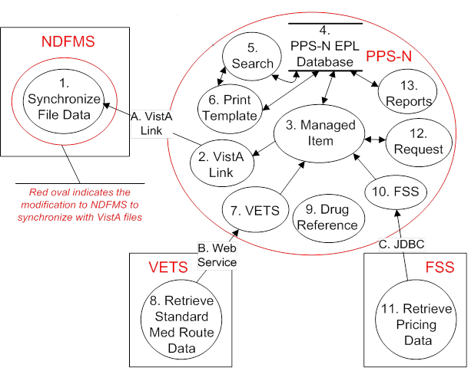

Figure 1: PPS-N Interaction Flow

The table below provides amplifying information for the interaction flow presented above.

Table 3: Interaction Flow Descriptions

| **Name** | **ID** | **Description** | **External Interface Name** |
| --- | --- | --- | --- |
| Synchronize File Data | 1 | This process is invoked by the PPS-N application’s VistA Link service to synchronize item updates from PPS-N into NDFMS’ VistA files | VistA Link, which allows external systems (such as PPS-N) to invoke MUMPS procedures on the NDFMS side |
| VistA Link | 2 | The service is used to send RPC messages from PPS-N to NDFMS | VistA Link, the interface mechanism between NDFMS and PPS-N |
| Managed Item | 3 | This service handles validation and create, read, update and delete (CRUD) operations with the PPS-N data entities | N/A |
| PPS-N Database | 4 | This database is used to persist all entities and information needed by the PPS-N application | N/A |
| Search | 5 | This service handles all simple and advanced search functionality for the PPS-N application | N/A |
| Print Template | 6 | This service handles CRUD operations for the ‘print template’ entity, used to persist advanced search criteria and result columns | N/A |
| VETS | 7 | This service is used to send web service requests to the VETS system, for the Standard Med Route data that it contains | Web services, the interface mechanism between VETS and PPS-N |
| Retrieve Standard Med Route Data | 8 | This process (not developed as part of PPS-N) is invoked by the PPS-N application’s VETS service to request Standard Med Route data | Web services, which allows external systems (such as PPS-N) to request data contained in the VETS data store |
| Drug Reference | 9 | This service interfaces with the COTS drug information database (also located within PPS-N) | N/A |
| FSS | 10 | This service is used to send Java Database Connectivity (JDBC) queries to the FSS system, for the pricing data contained in its database tables | JDBC, the interface mechanism between FSS and PPS-N |
| Retrieve Pricing Data | 11 | This process (not developed as part of PPS-N) is invoked by the PPS-N application’s FSS service to request pricing data | JDBC, which allows external systems (such as PPS-N) to query for data contained in the FSS database |
| Request | 12 | This service implements the item request management functionality for the PPS-N application | N/A |
| Reports | 13 | This service is used to manage reports | N/A |

## PPS-N Button List

The PPS-N application contains a large number of buttons and links. Below is a list of the buttons in PPS-N and their meanings. This list is alphabetical, not by window or function, as the buttons can display on many different windows and it depends upon user role whether a button is visible.

* **Accept Changes** – When a user makes changes to an item, those changes are displayed in a modification summary table so they can review and confirm the changes. This button provides that confirmation
* **Accept Changes to Product & Create Blank NDC** – Once the user has created a new product, and viewed the changes on the confirmation page, then can choose to accept those changes and also launch a blank NDC template form for creating a new NDC to be associated with the product they just created
* **Activate** – Activate an item that was previously inactive
* **Add** – Add a new search filter in Advanced Search
* **Add More Details** – Once the user creates a new item using a template (which only contains the primary information fields), they have an option to proceed to the edit table which provides access to all available data fields for that type item
* **Add New Row** – Add a new row in one of the multiple select boxes
* **Apply Changes to All Items** – When editing multiple items at the same time, as part of a single process, the user can apply changes to all items in the process
* **Apply Changes to Just This Item** – When editing multiple items at the same time, as part of a single process, the user can apply changes to a single item
* **Approve** – Approve any or all changes made to an item
* **Cancel** – Cancels the current action or process and returns to the previous page
* **Change OI** – Each product has an associated OI. When the OI for a product already exists, the user can search for and select a different OI
* **Change Product** – Each NDC has an associated Product. When the Product for an NDC already exists, the user can search for and select a different Product
* **Change Search Results Template** – Select the current advanced search template for editing or to create a new template
* **Create New NDC (from existing)** – Use an existing NDC and its details as a template for creating a new NDC
* **Create New NDC (from blank)** – Create a new NDC from scratch by using a blank NDC template form
* **Create New OI (from blank)** – Create a new OI from scratch by using a blank OI template form
* **Create New OI (from existing)** – Use an existing OI and its details as a template for creating a new OI
* **Create New Product (from blank)** – Create a new product from scratch by using a blank product template form
* **Create New Product (from existing)** – Use an existing product and its details as a template for creating a new product
* **Delete** – Delete an item, typically by removing it from a list
* **Delete Change Request** – Delete a change request
* **Down** – Move an item down in the list
* **Download**  – Download a file, typically in a CSV format
* **Edit Items** – Select to edit multiple items as part of a single process
* **Generate Name Fields Below** – When creating a new product, the user can automatically generate the VA Product Name, VA Print Name, and National Formulary Name
* **Generate New** – When viewing some report types, the user can create a new CSV file which can then be downloaded for viewing and/or saving
* **Generate OI Names** – When creating a new OI, this permits the user to automatically generate the PPS OI Name and VistA Orderable Item Name
* **Get Status** – Permits the user to view the status of a report generation process
* **Ignore** – In certain instances, the user will receive a warning about the item they have just submitted. This is just for information purposes
* **Inactivate** – Choose to inactivate an item that is currently active
* **Load Print Template** – Search preferences permits a user to personalize All Fields search templates for each item type. This action loads the appropriate fields for selection, based on the item type, and also loads an existing template when there is one
* **Login** – Login to PPS-N
* **Match Results** – After performing an FDB search, try and match the NDCs with an existing PPS-N product
* **Next Item** – Advance to the next item in the process, typically when performing edits on more than one item at a time
* **OK** – Final confirmation that an item has been saved to the database
* **Open Blank Template** – Create a new domain item using a blank form template
* **Overwrite** – Replace an existing item with a new item
* **Perform FDB Search** – Send a search query to FDB
* **Previous Item** – Back up to the previous item in the process, typically when performing edits on more than one item at a time
* **Reject** – Reject any or all changes made to an item
* **Remove** – Remove an item
* **Remove As Default** – Unmark the existing default advanced search template
* **Remove Row** – Certain data fields can have multiple entries and these are displayed as rows within a table. This action allows the user to remove an item (row) from the table
* **Retrieve Search Templates** – Change the current advanced search template by selecting another one from the list of available saved templates
* **Return** – Return to the previous page, typically so the user can make some other changes
* **Run Report** – When viewing some report types, the user can create a new report
* **Save Changes** – Save all changes
* **Save Template** – Once the user has created a new advanced search template or changed an existing template, they will assign a name for that template and then use this button to save it to the database
* **Save Work in Progress** – When the user is not done editing, they have the option to save their work and return to it later
* **Search** – Perform a search using the defined search criteria
* **Select OI** – When creating a new product using a blank product template form, this is used to search for and select an OI
* **Select Product** – When creating a new NDC using a blank NDC template form, this is used to search for and select a Product
* **Set As Default** – Define one advanced search template as the default template
* **Set Preferences** – Once the user has set or changed their user preferences, this action will save those preferences to the database
* **Submit** – Start the confirmation process for a new item or revisions to an existing item. In some cases, this also saves the item to the database
* **Under Review** – Place an item under review
* **Undo Changes** – Undo all changes made since the last time this item was saved
* **Up** – Move an item up in a list
* **View PMI** – View the Patient Medication Instructions for a specific drug
* **<** – Move an item from the right-side list to the left-side list
* **>** – Move an item from the left-side list to the right-side list

# PPS-N Application Pages

This section describes the Login Page, the Header and Main Navigation Bar, the Home Tab, the Manage PPS Tab, the Reports Tab, the Help Tab, and the Manage Application Tab (for Supervisor Roles only).

## Login Page

This section explains the Authentication Method used to authenticate users to the system.

### Instructions

The purpose of this screen is to provide an authenticated user access to the system. Note that authentication is handled through the IAM SSOi service. PPS-N application doesn’t assign individual permissions to users.  Instead, PPS-N defines a number of roles for its users and associates a set of permissions with each of them.

### Authentication Explanation

Application authentication is handled by IAM SSOi.

If the authentication is successful, IAM SSOi returna the user information, which is used by the application to determine the user's roles. On successful login, the system transfers the user to the Home page of the application.

The login page is shown below.

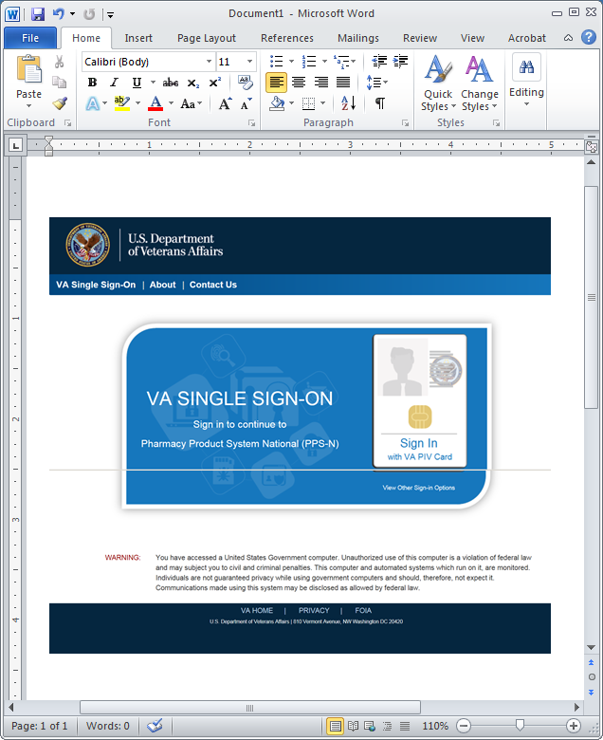

Figure 2: IAM Single Sign On Login Screen

## 

## Header and Main Navigation Bar

All PPS-N pages share a common header, main navigation bar, and information bar.

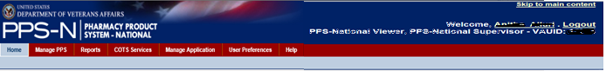

Figure 3: Header and Navigation

The left part of the header includes the standard VA logo, application acronym and name. The right part shows the user name, the Logout link, and the user’s assigned role and location below the name.

### Login / Logout

The application login process is handled by a separate system (VA Single Sign-On).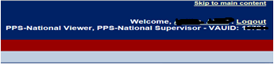

In the upper right corner of the application screen are two lines of text:   
The first line has “Welcome, *user’s-name* . Logout .” The user’s first name will be displayed. Both the first name and Logout will be links.  
The second line has the user’s assigned roles, e.g. “PPS-National Manager ” and the VAUID

The first name link can be clicked to view detailed information on the user account. This page will detail the following information:

* First name – The first name of the user, sent by IAM SSOi.
* Last name – The last name of the user, sent by IAM SSOi
* VAUID – The Active Directory VAUID of the user, sent by IAM SSOi
* Roles – The user’s assigned roles, as assigned by the application administrator(s). All VA users are assigned the default Viewer role.

The Logout link on the first line will allow a user to manually logout of the application.

### Main Navigation Bar

The main navigation bar includes seven main tabs: Home, Manage PPS, Reports, COTS Services, Manage Application, User Preferences, and Help.

### Information Bar

The information bar includes a locational breadcrumb (on the left side) and a link to context sensitive help (Page Help) for the respective web page you are on. The application currently includes a Provide Feedback link which generates an e-mail that you can use to contact PBM staff. This link may or may not exist in the production version of PPS-N.

## 

## Home Tab

The Home tab is the first page the user sees after logging in to PPS-N. Note that there is a User Preference to change the default login page to the Search page if the user prefers.

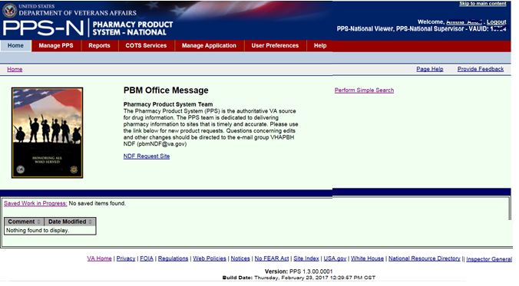

Figure 4: Home Page

The home page displays the following content:

* An optional image and message from the PBM office
* The user’s “Saved Work in Progress”
* Helpful links (at the bottom of the page)
* Application version information (below the helpful links)
* A link to the Simple Search page (Perform Simple Search)
* The application’s messaging status when appropriate

Saved Work in Progress

The system may automatically save work in progress upon system time-out or a user may elect to save during various processes by clicking the “Save Work in Progress” button when it is available. Saved sessions will be displayed in the Saved Work in Progress table on the home page.

* The Comment field includes the name the user assigned to the saved work or“AUTO-LOGOUT AUTO-SAVE” which designates the work was saved upon a user’s session time-out.
* The Date Modified field presents a date-time stamp indicating when the item was saved.

The user can click the link in the “Comment” column to open this saved session from the Home page. The user can also click the link “Saved Work in Progress” and PPS-N will display the Saved Work in Progress tab.

Messaging Status

To perform maintenance tasks, a system administrator may turn off communication with the NDFMS server. When this occurs, users will be notified on the Home page as shown in the previous figure. New items and modifications to existing items will be saved to a queue to be processed once the connection is re-established.

## Manage PPS Tab

The Manage PPS tab is where most of the drug management functions are accomplished. This includes searching for and editing/adding new drugs and their attributes and domains, performing the approval process for those drug and attribute additions or revisions, and continuing work that was previously saved.

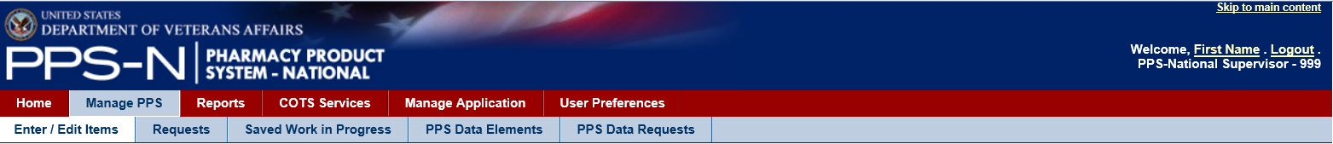

Figure 5: Manage PPS Tab

The five tabs found under the Manage PPS tab include:

* Enter/Edit Items – search for, edit and create new items.
* Requests – review and approve item additions or revisions requiring approval.
* Saved Work in Progress – review work that was saved for later completion.
* PPS Data Elements – search for, edit and create new domains.
* PPS Data Requests – review and approve domain additions or revisions requiring approval.

### Enter / Edit Items Tab

The Enter / Edit Items tab provides the means for searching the system for drug information. From this page, search result items can then be selected for review or edit, and the user can choose to create new items.

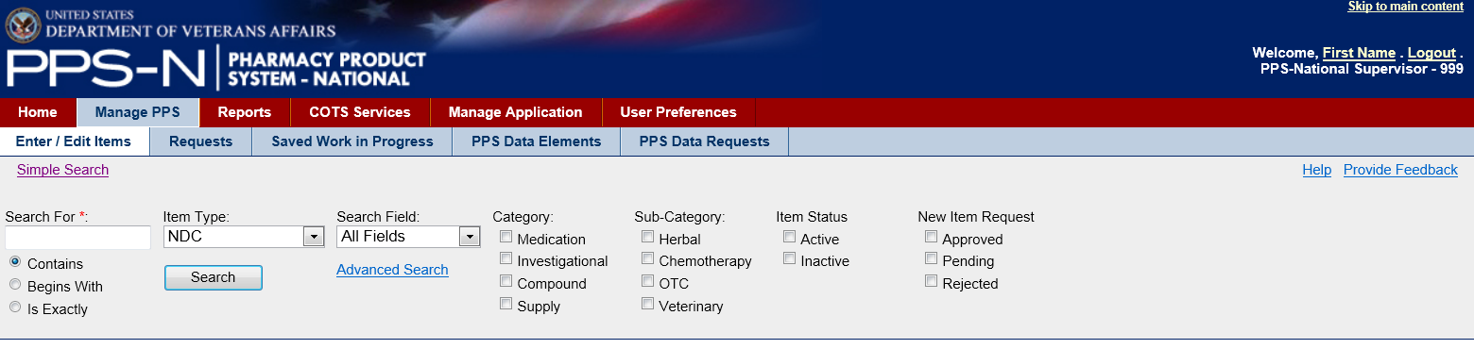

Figure 6: Simple Search

The search process includes the following steps:

* Enter text in the “Search For” field
* Select the “Item Type”
* Select the “Search Field”
* Select any applicable filters and options
  + Category
  + Sub-Category
  + Item Status
  + New Item Request
* Click the “Search” button

These steps are further explained below.

1. Select an Item Type

The Item type consists of three entries relating to the three main types of drugs in the system: NDC, Product, or Orderable Item.

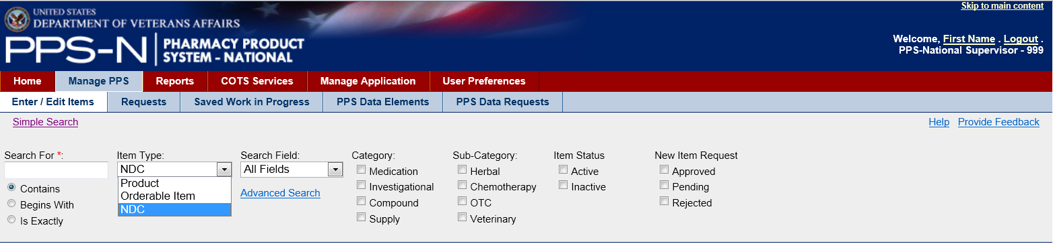

Figure 7: Simple Search Select Item Type

1. Select a Search Field

The Search field dropdown list is dependent upon the chosen item type. If the user chooses NDC as the item type then the Search Field dropdown will populate with searchable NDC fields. If Product is chosen as the item type, then the Search field dropdown will populate with searchable Product Fields. Likewise, if Orderable Item is the selected item type, then the Search Field dropdown list will contain searchable OI fields. The actual searchable fields for each item type are shown in the table below the next figure.

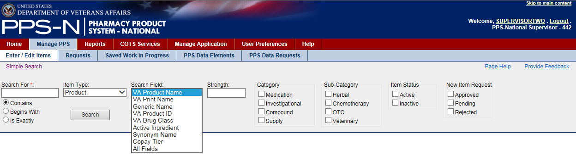

Figure 8: Simple Search Select Search Field

Table 4: Entity Types and Respective Search Fields

| **Available Entity Types** | **Search Fields** |
| --- | --- |
| **Product**  Selection will expose the “Strength” criteria field. | All Fields  VA Product Name  VA Print Name  Generic Name  VA Product ID  VA Drug Class  Active Ingredient  Synonym Name  Copay Tier |
| **Orderable Item**  Selection will expose the “Dosage Form” criteria field. | All Fields  PPS OI Name  OI Synonym |
| **NDC** | All Fields  NDC  UPC/UPN  Trade Name |

1. Select Other Filters

Following the Search Field, there are a number of other selectable search filters. First, if the user chose Product as the item type, then a text field will appear for entering a specific Strength to search for. Similarly, if the user selected Orderable Item as the item type, then a Dosage Form text field will become available. After that, the user can choose to search the drug database based on the specified Category, Sub-Category, Item Status, and New Item Request (status). For all four of these filter types, the user can choose any combination of items, including multiple choices in each filter type.

There is one other set of filters that can be used with the search. Just below the Search For text field are three radio buttons: Contains, Begins With, and Is Exactly. These indicate where the search string can appear in the result.

* Contains – return search results where the search string appears anywhere in the searchable fields
* Begins With – return search results where the search string appears at the beginning of the searchable fields
* Is Exactly – return search results where the search string matches exactly the searchable field

1. Enter Text in the Search For Field and Perform a Search

To perform a search, the user enters a string in the “Search For” text field which is a required field. After selecting any other filters, the user then clicks the “Search” button to perform the search. For the Search For text field, the user may use two wildcards, _ (underscore - any single character) and % (percent - any number of characters).

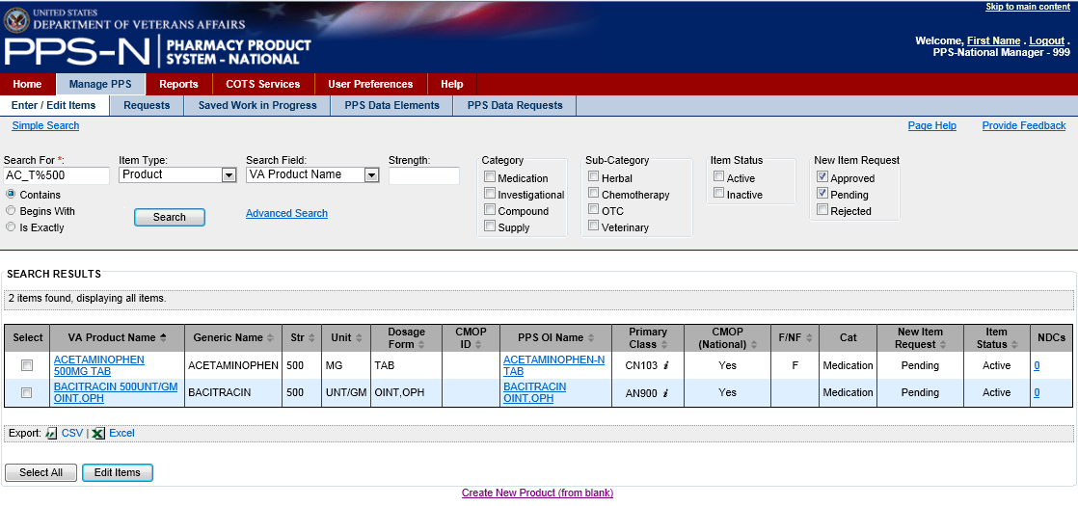

Figure 9: Simple Search Results

In the example above, the user entered AC_T%500 in the Search For text field. It returned two matching VA Product Names (note the Search Field is VA Product Name), ACETAMINOPHEN 500MG TAB and BACITRACIN 500UNT/GM OINT, OPH. Both of these contain AC(any single character wildcard)T followed by 500 somewhere in the name (based on % wildcard). Note that if the user had selected the “Begins With” radio button below the “Search For” text field, the search would have only returned ACETAMINOPHEN.

1. View Search Results

The search results are shown below the search filters and include those items that matched the specific Search For text field entry and the other filters. The results are presented in a table with various columns depending on the selected item type and search field. For example, in the figure above, the items presented in the table are specific to Product searches based on VA Product Name. Selecting a different Search Field or Item Type will result in potentially different drug information being displayed in the table. Likewise, selecting a different Search Field can result in different columns of information being displayed.

Export Search Results

Below the search results table, there is an option to export the search results in either CSV or Excel format. The user should click the desired format link in the export panel, shown below, and then use the buttons in the resulting dialog box to Open or Save the results.



Figure 10: Export Bar

Review and Possibly Edit Drug Information

Also note that the rows within the search results table contain one or more hyperlinked items. This provides a means for the user to access and review and/or edit that specific item by clicking the link. The page shown below is the edit product page that displays attributes about the product, and allows the user to make any necessary changes to that item.

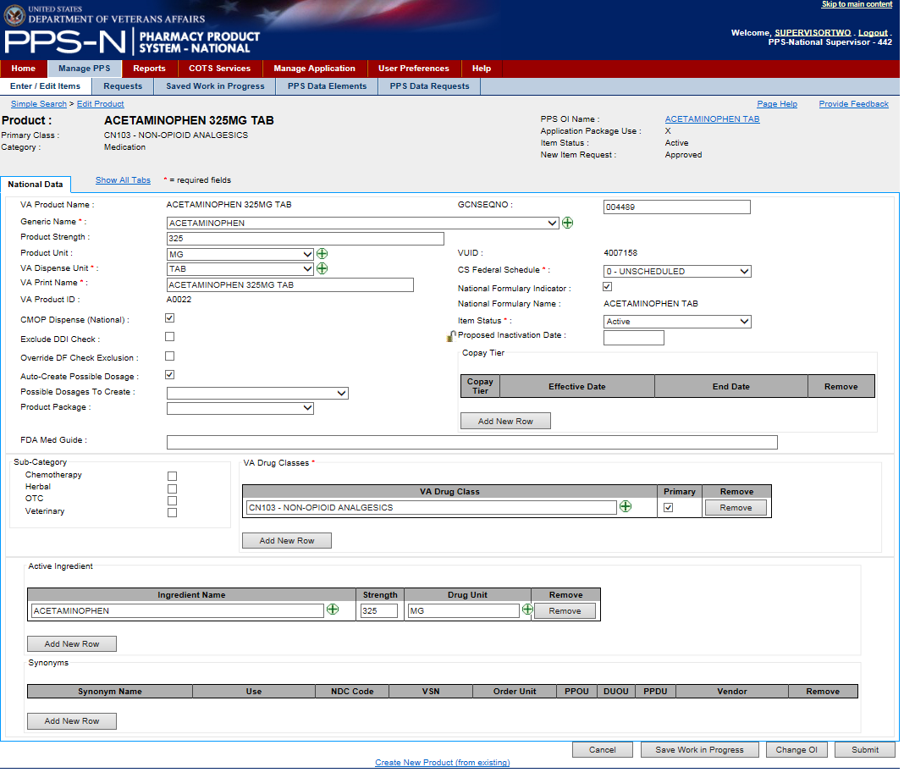

Figure 11: Edit Item

The drug information is arranged in a series of tabs. For a product, the major data items are displayed on the National Data tab as shown above. There are also seven other tabs which contain information that might occasionally need to be reviewed or changed. In this case, the user will select the Show All Tabs link that is located to the right of the National Data tab. Selecting that link will display the other remaining tabs as shown below.



Figure 12: Access Other Drug Item Tabs

The user can maneuver through these tabs by clicking the name on any of the tabs. Additionally, the user may click the Hide All Tabs link to return to viewing just the National Data tab information.

While viewing the information, the user can select and change almost all of the data except for those items that are displayed as text only. If changes are made, the user then clicks the “Submit” button at the bottom right side of the page and this will continue through a process to validate the changes, allow the user to view and if necessary revise the changes, and then finally submit the changes to the database.

There are other processes that can be performed while viewing drug information. Each of these is summarized here and described in detail later in this section.

1. While viewing an Orderable Item, it will have a Products tab that displays a table with those products associated with that Orderable Item. This tab provides a “Move Products” button that starts a process for assigning any selected (checked) products to a new Orderable Item.
2. While viewing a Product, it will have an NDCs tab that displays a table with the associated NDCs. This tab provides a “Move NDCs” button that starts a process for assigning any selected (checked) NDCs to a new Product.
3. While viewing the Product’s NDCs tab, there is also a “Copy NDCs to New Product” button that starts a process for making a copy of the selected (checked) NDCs, assigning them to a new Product, and then requiring the user to make some changes to the NDCs.

Add New Items

After performing the search for an item type, such as products, the user may determine that the appropriate drug does not exist in PPS-N and needs to be created. The user can then choose to create a new item, either from scratch using a blank template or by using an existing item as a template. Each of these is described below:

1. Create New [Item Type] from Existing

While the user is reviewing an existing item, there is a link at the bottom of the page to create a new item using this current selected item as a template. To use this existing item, click the “Create New [item type] (from existing)” link.



Figure 13: Create New [Item Type] from Existing Link

1. Create New [Item Type] (from blank)

If the user performed a search and did not find any items closely related to the new item, then the user could choose to create a new item using a blank template (almost no fields are pre-populated). Below the search results table, click the “Create New [item type] (from blank)” link as shown below.

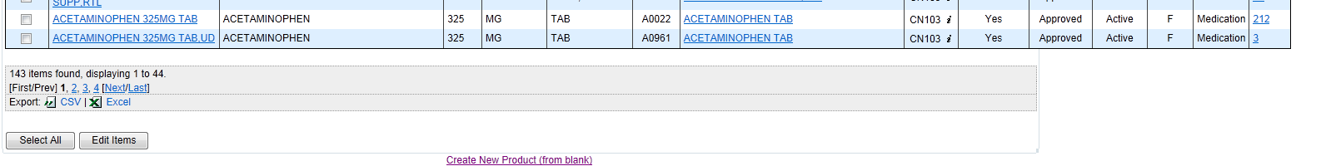

Figure 14: Create New [Item Type] from Blank Link

Clicking this link will present a new item template for the user to complete. As an example, the Add New National Product template is shown below.

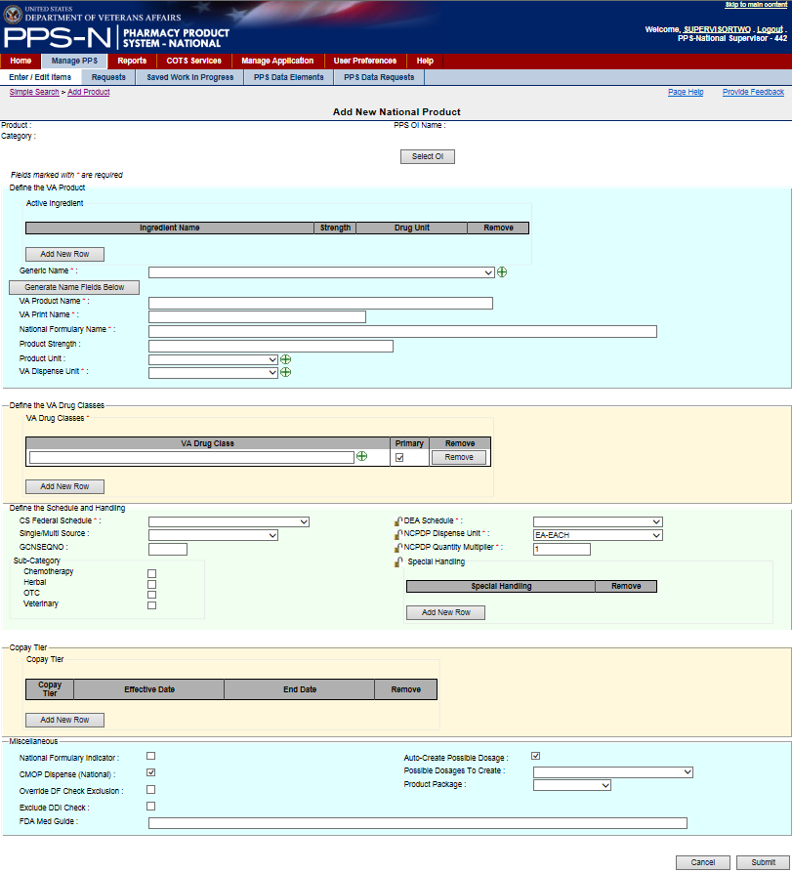

Figure 15: Create New Product Template

Just below the title Add New National Product, the user will note some field labels without subsequent content. This is considered the template header. In the template above, the labels in the header include “Product:” (name), “Category:”, and “PPS OI Name:” (appropriate parent name). These items will be filled in by PPS-N while working on the remainder of the template.

Just below the template header, the user will note a button to select the appropriate parent. In the template above, this button is named “Select OI”. At some point in the process of completing this template, the user will need to click this button which will spawn a new process so the user can search for and select the parent for this new item. That process will return the user to this template and fill in the text following the label PPS OI Name. It’s recommended that this process of selecting an appropriate parent be performed first.

Next on the page is text stating that Fields marked with * are required. The user will then note that certain fields on the template have field labels that are followed by the * (red) asterisk. This is how PPS-N denotes those fields that the user must complete before saving the item, or else PPS-N will produce an error message.

The first field on the product template is Active Ingredient and this is a multiple. The user can click the “Add New Row” button to produce a row with the necessary fields in it. The user will then complete each field, and also has the option to add more ingredients by again clicking the “Add New Row” button. Note that this field does not have a red asterisk so it is not required. However, to use the “Generate Name Fields Below” button, which will automatically populate the text for up to five fields below the button, the user must enter an Ingredient with its “Name”, “Strength” and “Drug Unit”.

Similarly, to use the “Generate Name Fields Below” button, the user must first select a “Generic Name” from its dropdown list. This field is marked with a red asterisk, so the user must perform this selection anyway. The user can then select the” Generate Name Fields Below” button to populate the “VA Product Name”, “VA Print Name”, “National Formulary Name”, “Product Strength”, and “Product Unit”, if appropriate. These items can also be entered by typing text in those fields, and they can also be changed after using the button to fill in the fields.

The user will then proceed through the rest of the fields on the template making the appropriate entries, and paying special attention to those marked with the red asterisk which must be completed. After filling in the required and any other desired fields the template, in this case a product, will look something like the one shown below.

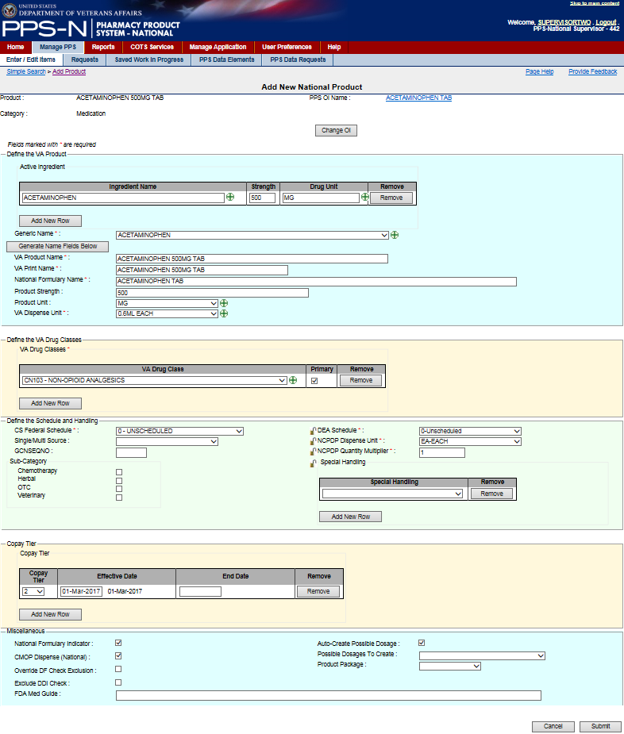

Figure 16: Enter New Product Fields

When the user has completed all required and desired information on this template, the user then clicks on the “Submit” button at the bottom right side of the page. This will display the confirmation screen shown below.

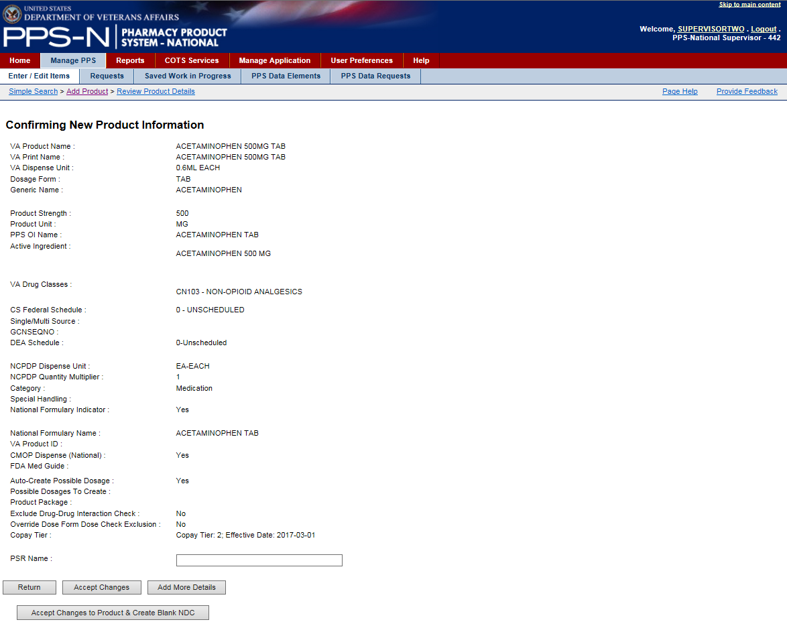

Figure 17: Create New Product Confirmation

After reviewing the information to make sure it’s correct, the user will note four buttons at the bottom of the page:

* “Return” (to the previous page) – allows the user to go back and make a needed change.
* “Accept Changes” – accepts the changes, saves the item to the database, and returns to the search results page.
* “Add More Details” – saves the item to the database, and then proceeds to the Edit page where the user can add additional information about this item.
* “Accept Changes to Product & Create Blank NDC” – saves the item to the database, and directs the user to a blank child template so that the user can create a child using this item as its parent.

Perform an Advanced Search

As illustrated in the following, to the right of the “Search” button is a link to the Advanced Search page which provides options for searching on multiple fields, and other fields that are not available in simple search.

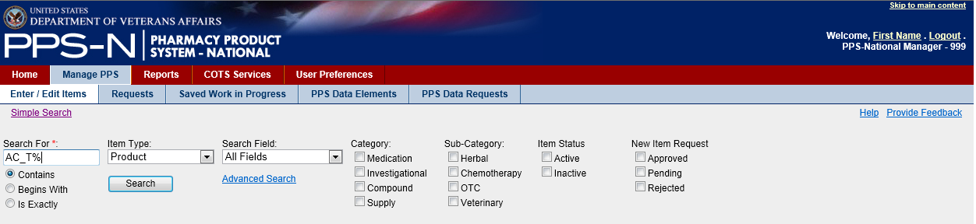

Figure 18: Advanced Search Link

Selecting the “Advanced Search” link will display the Advanced Search page as shown below.

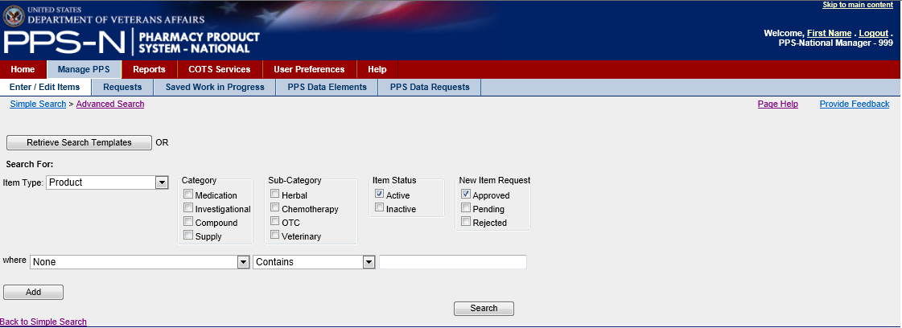

Figure 19: Advanced Search Page

1. Retrieve Search Templates

If the user has saved previous advanced searches, they may select one of these templates by clicking on the “Retrieve Search Templates” button which will display the Search Templates page.

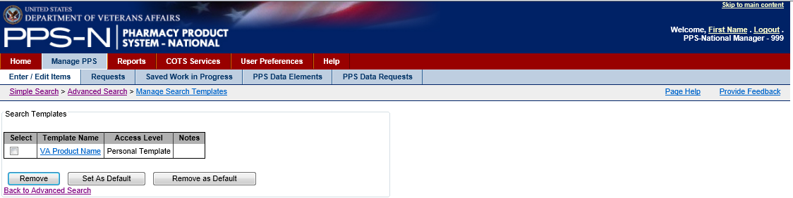

Figure 20: Search Templates

The available search templates will be displayed in the table shown above by Template Name, Access Level, and Notes.

* Template Name – Text describing the search results template – the user should be specific so that they can distinguish multiple templates
* Access Level – Personal Template or National System Template – the user can create Personal Templates – the Supervisor can create National System Templates which become available to all users but these users cannot modify or delete them
* Notes – Textual notes that further describe the template

This page provides three options for the user:

1. Personal Templates can be removed be checking the Select checkbox and then clicking the “Remove” button.
2. A default template can be defined, and this template will automatically be displayed every time the user accesses the Advanced Search page. The user can still change all of the display items.
3. A default template can be deselected by checking the Select checkbox and then clicking the “Remove as Default” button. This will not delete the template.
4. Set the Filters

The user will select the Item Type from the dropdown list, and then select the appropriate Category, Sub-Category, Item Status and New Item Request (status) filters.

1. Set the Search Parameters

The user will then set the search parameters for specific fields based on the Item Type. In the figure below, the user selected NDC as the Item Type, so the first parameter field becomes a dropdown list of all available NDC fields.

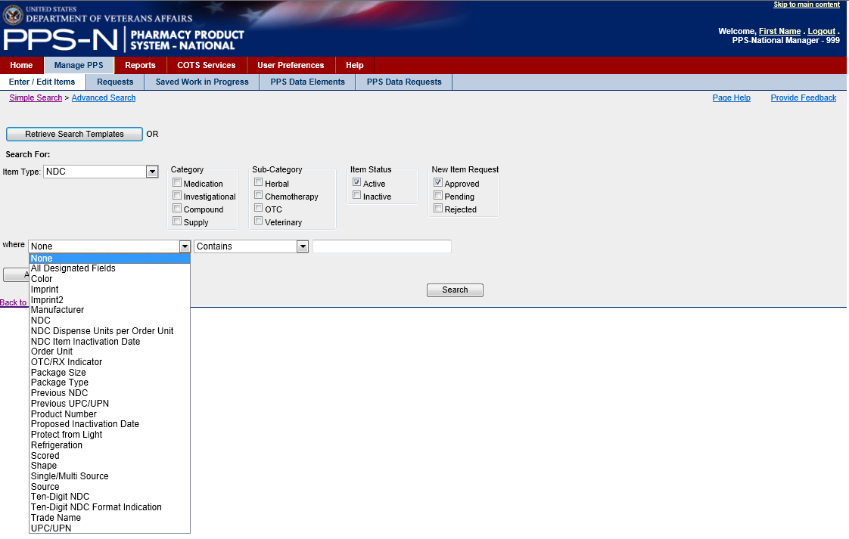

Figure 21: Advanced Search Dropdown List

The user will select the appropriate NDC field in the dropdown list and the search field constraint (Contains, Begins With, Is Exactly) in the second dropdown list. Depending on the NDC field selected, the last field of the three shown could become a dropdown list (e.g., Manufacturer), a text field as shown, or a checkbox. The user will then select the appropriate response or enter the text string. The result would appear similar to the following:

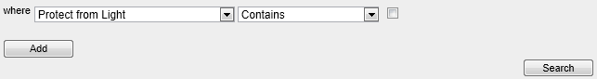

Figure 22: Advanced Search Parameter

The user can perform the search on this one field by clicking the “Search” button, or the user can decide to add another search parameter. Typically, the user would perform the search and if too many results were returned, the user would add another parameter by clicking on the “Add” button which will present the following:

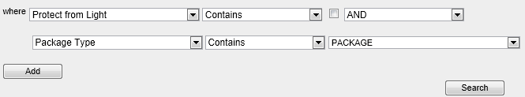

Figure 23: Advanced Search Multiple Parameters

As in the example above, when the user clicks the “Add” button, the logical operator (AND/OR) dropdown list is placed at the end of the first selection, and then a second row is added so that the user can select other parameters.

How the Logical Operators Work

The advanced search capability allows for the use of two logical operators:

* AND – display search results that match the first item AND the second item
* OR – display search results that match all parameters before the operator (OR) or after the operator

In the example below, PPS-N will match all database items that have Protect from Light unchecked AND Package Type of Box as well as (OR) all items that have a Package Size of 100.

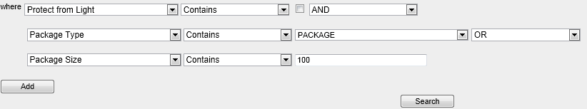

Figure 24: Advanced Search And/Or Logic

1. Execute the Search

Once the user is satisfied with the parameters, then the user will click the “Search” button which will display the search results in a table below the parameters as shown below:

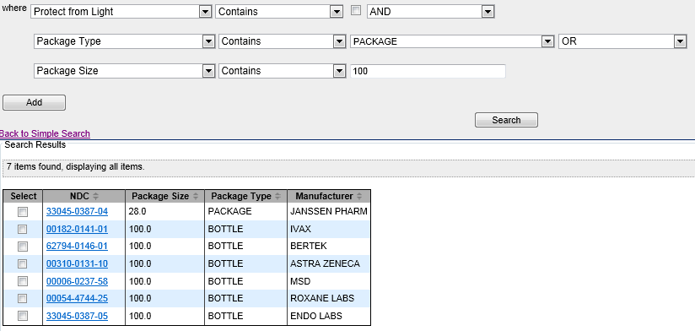

Figure 25: Advanced Search Results

1. Export Search Results

If the user wants to export the search results, the user will click the appropriate button shown in the export panel: 1) CSV or 2) Excel  
  


Figure 26: Advanced Search Export Bar

This will launch a dialog that allows the user to view or save the results.

1. Save the Search Results Template

As described earlier, the user may save the search parameters as a search template. Below the search results table, the user will note the following:

* Save As – enter the name of the search template
* Notes – optional text to describe the template
* Save At – dropdown list for defining the access level of search template. Personal Template is just for the user while National System Template is provided for those users with PPS-N supervisor role to save templates that are made available to all users



Figure 27: Save Advanced Search Template

Once the user enters the name, optional description, and the template access level, the user will then click the “Save Template” button.

1. Change Search Results Template

The advanced search capability also allows the user to define the data fields that should be displayed in the search results table, and also saved in the search results template. To accomplish this the user will click the “Change Search Results Template” button. This will launch a page similar to the following (for NDC).

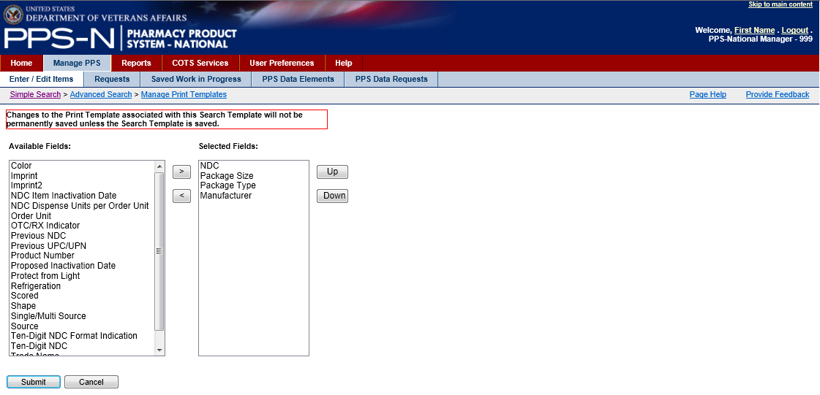

Figure 28: Change Advanced Search Template

The Available Fields panel on the left lists those fields that are available for selection. The Selected Fields panel displays those data fields that have already been selected and the order in which they should be display in the table. To make changes, the user will highlight the items in the Available Fields panel that they want to include in their search results and use the right “>” button to move the item(s) to the Selected Fields panel. If needed, the user may move an item back to the Available Fields panel using the left “<” button.

The user may also reposition the items in the Selected Fields panel by selecting an item and then using the “Up” and “Down” buttons.

Once the user is satisfied with the items in the Selected Fields panel, the user will click the “Submit” button to save the changes.

Move Products or NDCs

While viewing drug information, the user will have an option to move the children of that item to a different parent (Product or Orderable Item). .

1. While viewing an Orderable Item, it will have a Products tab that displays a table with those products associated with that Orderable Item.

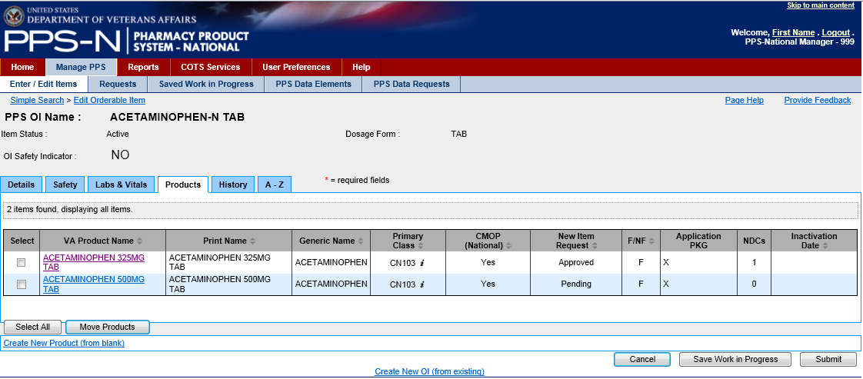

Figure 29: Processes on the Products Tab

This tab provides a “Move Products” button that starts a process for assigning any selected (checked) products to a new Orderable Item. The process is as follows:

1. Select one or more of the Products (check the checkbox in the Select column).
2. Click the “Move Products” button.
3. Fill in the “Search For” text box, select the appropriate parameters and filters, and click the “Search” button.

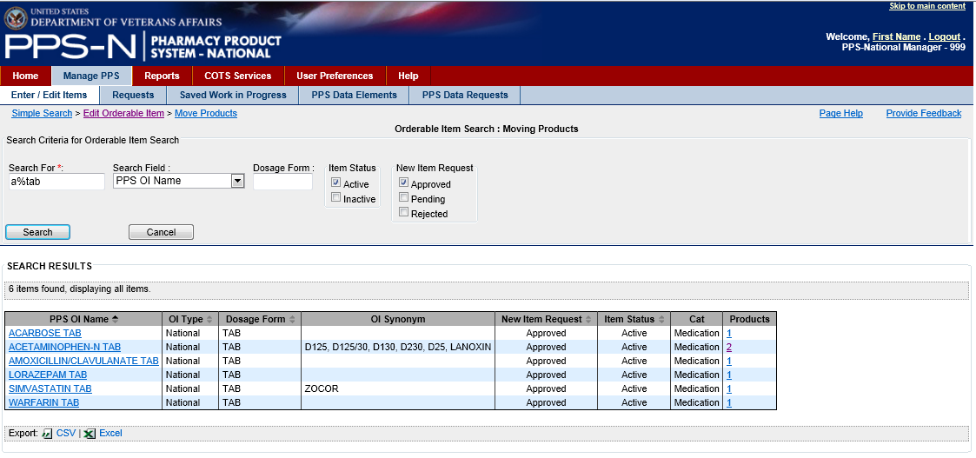

Figure 30: "Search For" Text Box

1. Select the link of the desired Orderable Item in the PPS OI Name column.
2. When returned to the Products tab, verify that the Products have been removed from the table.
3. While viewing a Product, it will have an NDCs tab that displays a table with the associated NDCs. This tab provides a “Move NDCs” button that starts a process for assigning any selected (checked) NDCs to a new Product.

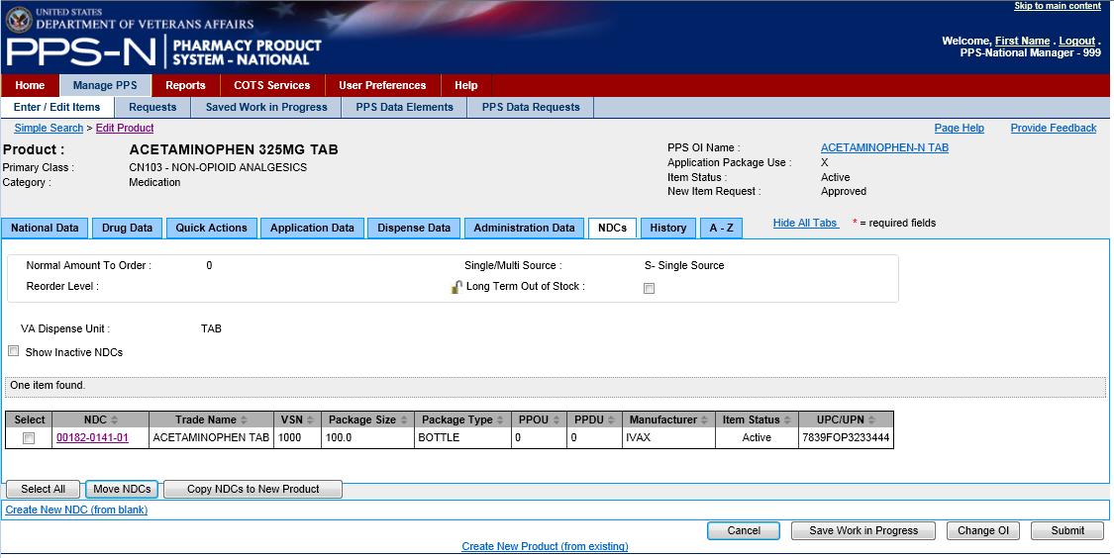

Figure 31: Processes on the NDCs Tab

This process is similar to that described above for Moving Products.

1. While viewing the Product’s NDCs tab (shown above), there is also a “Copy NDCs to New Product” button that starts a process for making a copy of the selected (checked) NDCs, assigning them to a new Product, and then requiring the user to make some changes to the NDCs. The process is as follows:
   1. Select one or more of the NDCs (check the checkbox in the Select column).
   2. Click the “Copy NDCs to New Product” button.
   3. On the Add New National Product page, make the appropriate changes since you are creating a new product.
   4. Click the “Submit” button.
   5. Review the information shown on the Confirmation page and then click the “Accept Changes to Product & Edit NDCs” button.
   6. On the Add New NDC page, make the appropriate changes since you are creating a new NDC and click the “Submit” button.
   7. Review the information shown on the Confirmation page and then click the “Save NDC” button.
   8. If more than one NDC was selected in step a above, continue steps f and g until you reach the final confirmation page which will have the “Save Final NDC” button for selection.
   9. Click the “Ignore” or “OK” button on the Committed Changes page.

### Requests Tab

Once a new item, such as a Product, has been created and saved to the database, its approval state is marked as “Pending”, indicating that it needs to be reviewed and approved. This is also the case for some item modifications where the user makes a change to an existing item and that change also requires review and approval. These items are now considered approval requests, and are made available to users with appropriate permissions to approve such requests. To view these “Pending” requests, the user selects the Requests tab. As shown below, the items in the ‘Pending’ state are organized in various sub-states so that the user can use these as filters when they perform a search for the pending requests.

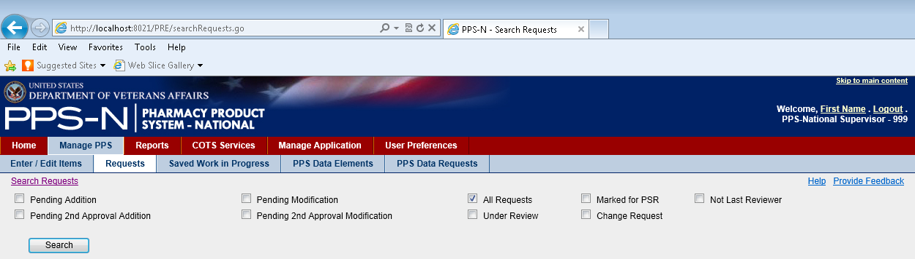

Figure 32: Requests Tab

1. Select the Appropriate Filter Checkbox(es)

To view the requests, the user will select the appropriate checkbox(es) and then click the “Search” button. Descriptions of the various request type filters (sub-states) are below:

Table 5: Request Type Filters

| **Request Type Filters** |  |
| --- | --- |
| **All Requests** | This is the default check box selection, and it will display all requests that are pending action. |
| **Pending Addition** | Choose this filter to display those pending requests with a Request Type of Addition and a Request Status of Pending Approval. |
| **Pending 2nd Approval Addition** | Choose this filter to display those pending requests with a Request Type of Addition and a Request Status of Pending Second Approval. |
| **Pending Modification** | Choose this filter to display those pending requests with a Request Type of Modification and a Request Status of Pending Approval. |
| **Pending 2nd Approval Modification** | Choose this filter to display those pending requests with a Request Type of Modification (an existing item was changed) and a Request Status of Pending Second Approval |
| **Under Review** | Choose this filter to display those requests that were placed Under Review |
| **Marked for PSR** | Choose this filter to display those requests that were Marked for PSR (Peps Second Reviewer). |
| **Change Request** | Choose this filter to display those requests that were marked as a Change Request |
| **Not Last Reviewer** | Choose this filter to display those requests for which you were not the last reviewer, meaning you can approve any of those that are displayed. |

1. Review Requests

When the user clicks the “Search” button on the requests page, PPS-N will display those requests that matched the filters. In the example shown below, the user searched for “All Requests” and there was only one in the database. If the search had returned no matches to the filter settings, then PPS-N would have displayed “Nothing found to display” below the table. In that instance, the user should select different filter settings and click the “Search” button again.

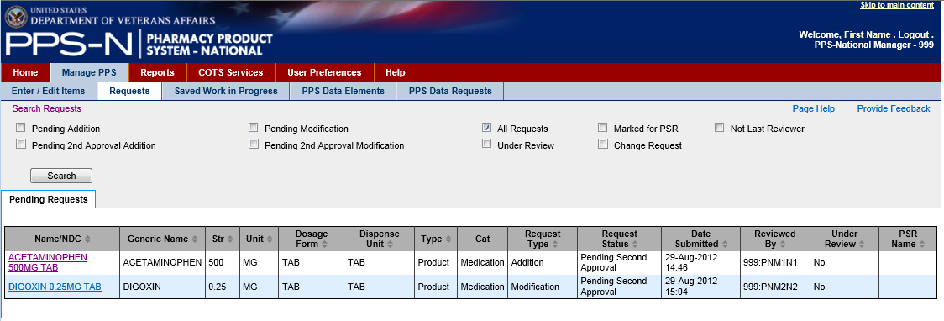

Figure 33: Requests Search Results

1. Approve Requests

The search results table provides basic information on each request as shown above. As a request, the user will note three relevant columns, “Request Type”, “Request Status”, and “Reviewed By”.

* “Request Type” – Modification (existing item changed) or Addition (new item created)
* “Request Status” – Pending Second Approval
* “Reviewed By” – the name and id of the user that created the item or made the change. This is important to note because a user cannot provide a second approval of an item they changed or created.

The user clicks on the appropriate item link in the first column labeled “Name/NDC” When selected, PPS-N will display the addition or modification page for the item chosen, and it is displayed similar to the previously described edit or view pages except that it contains one or more new tabs and some different buttons.

Product Addition Request

In the Product Addition Request shown below, the user is presented with the typical edit page except that a new tab has been added, “Change Request”. This new tab includes the first and last name of the user that created the new item along with a block where they might have entered comments relevant to this new item request.

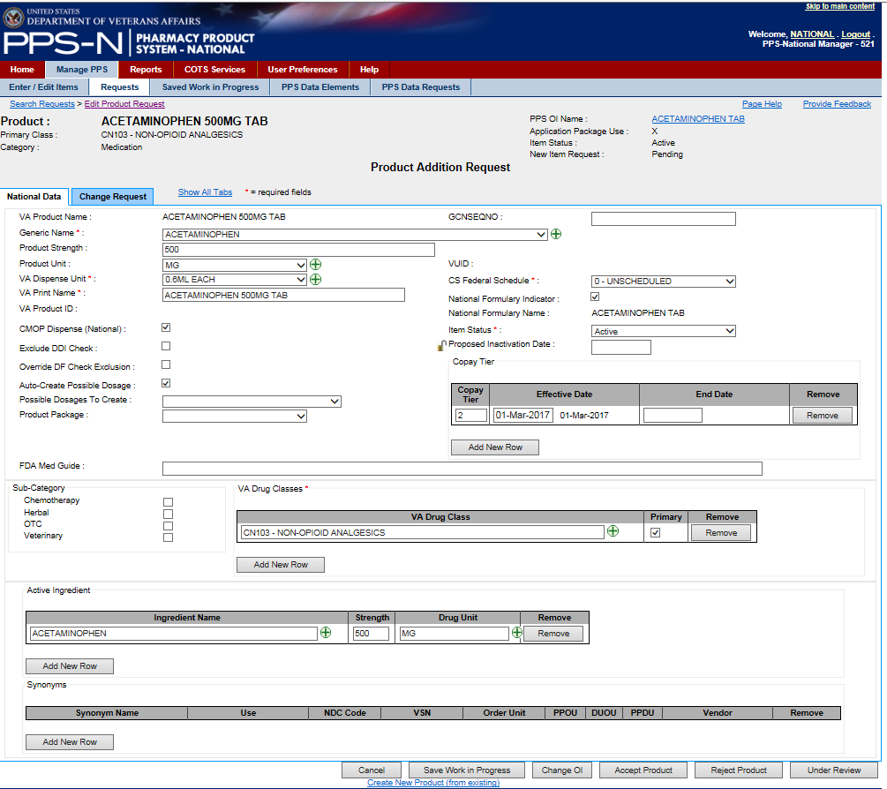

Figure 34: Approve Addition Request

The bottom of the page contains the typical three buttons: “Cancel”, “Save Work in Progress”, and “Change OI”. However, they are also presented with some new buttons. Typically, the user will review the information presented on the National Data tab (and others if they so choose) and then click the “Accept Product” button (for a product request). They may also make changes before they accept the product request. In this case, if they select a second review field, this item with the new changes (after approval in the next step) will again be placed in the “Pending” state and be submitted for review by another second reviewer.

1. Confirm Request Approval

This screen is used to allow the user to confirm the changes that they made on the previous screen and to add comments as well.

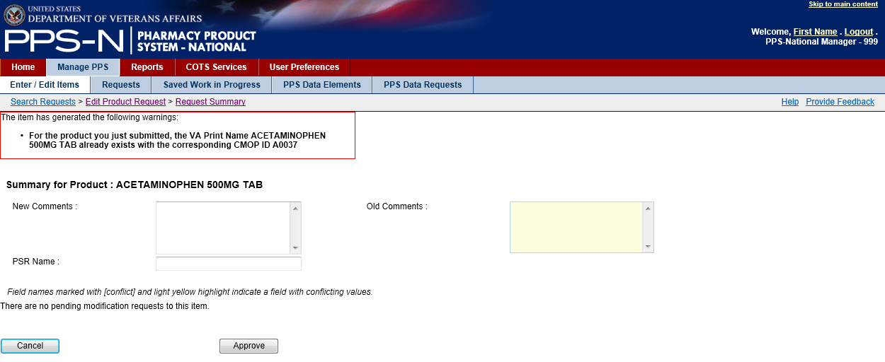

Figure 35: Approve Request Confirmation

1. Reject the Approval Request or Place Under Review

Additionally, the reviewer has two other buttons available:

* “Under Review” – take no action at this time other than place this item in the “Under Review” state which allows the user to return to the Requests tab at a later time and use the “Under Review” filter to locate this item.
* “Reject Product” (for a product) – reject the new addition request. This will present a new page so the user can provide details concerning this rejection. A sample of this page is below.

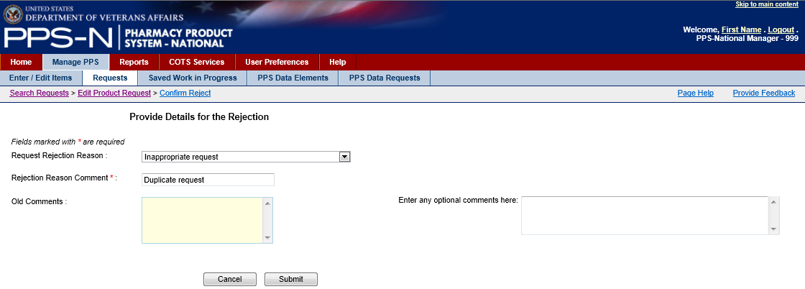

Figure 36: Rejection Details

The user will select one of the three choices in the “Request Rejection Reason” dropdown list, enter a “Rejection Reason Comment”, and potentially enter optional comments in the block on the right. The user will then select the “Submit” button to save this rejection update to the database.

Modification Request

In the Product Modification Request shown below, the user is presented with the typical edit page except that there are two new tabs added, “Change Request” and “Pending Modification”. This latter tab presents a table of the modifications.

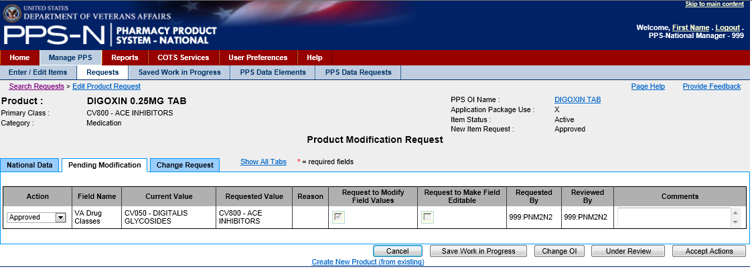

Figure 37: Pending Modification

Note that the table identifies the field that was changed, the current and requested values, which user requested the change, and the reviewer/approver information. It also includes an “Action” column where the user can mark each individual proposed modification as “Approved” (approve the change), “Pending” (leave it in the pending state), or “Rejected” (reject the change). The user will review the item(s) in this table, make any appropriate changes in the Action column, added comments if they choose, and then either click the “Accept Actions” button or place this item “Under Review”.

### Saved Work in Progress Tab

Occasionally, the user will be in the middle of modifying an item when they need to do something else. Therefore, on the item edit page, they selected the “Save Work in Progress” button and gave it a name or provided a comment. When they return to PPS-N, they can choose the Saved Work in Progress tab and retrieve previously saved items listed in the table as shown below. It should be noted that item modifications will be saved automatically if a system time-out occurs, and en entry will be placed in the Saved Work In Progress table.

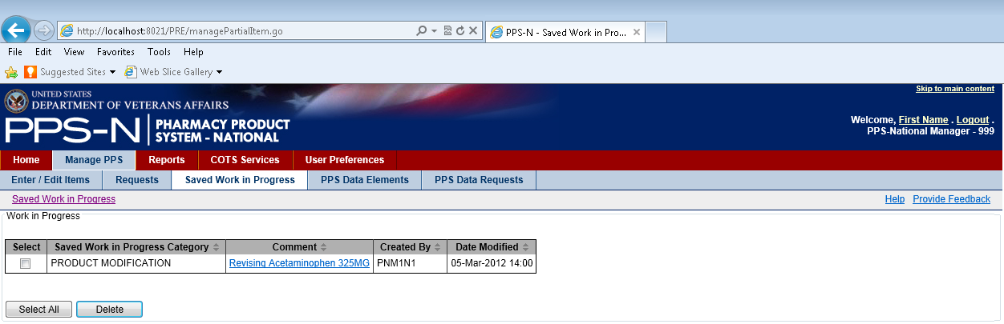

Figure 38: Saved Work in Progress

Selecting the link in the “Comment” column will return the user to the appropriate edit page and the user can continue with more changes and finally submit the item.

There is one cautionary note. Presently, once the user selects the item in the “Comment” column, it will be removed from the table. Therefore, the user must then complete the edit process for that item or once again use the “Save Work in Progress” button to place it back in this table.

### PPS Data Elements Tab

Rather than enter text for every data field in PPS-N, it includes a number of drop down lists that make it easier for users to select the appropriate entry while ensuring consistency from user to user and drug to drug. These drop down lists involve what PPS-N terms drug “domains” but they are just lists of related data elements. These drug domains are available in the PPS Data Elements tab.

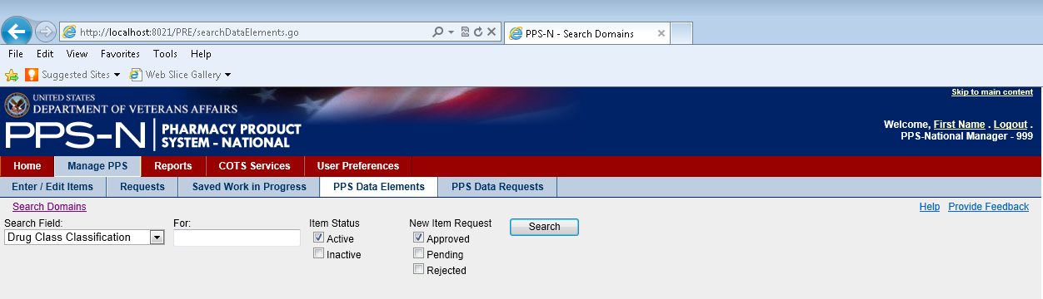

Figure 39: PPS Domain Search

1. Search Domains in PPS Data Elements

There are multiple domain lists that can be managed within PPS-N. The “Search Field” dropdown list shown below lists the types of domain that can be viewed or edited. It should be noted that the Standard Med Route Name items can only be viewed, not edited.

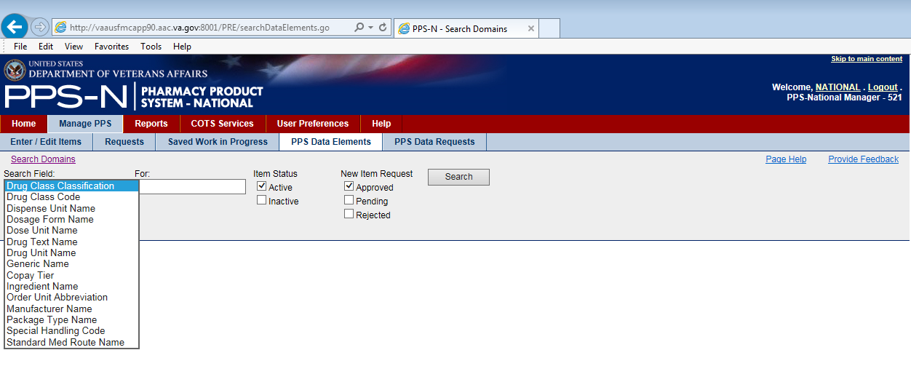

Figure 40: PPS Domain Search Fields

1. Review Search Results in PPS Data Elements

After the user has selected the appropriate domain in the “Search Field” dropdown list, the user will then enter the search criteria text in the “For” textbox and click the “Search” button. The results will be displayed in the search results table as shown below. Note that the text entered in the “For” textbox can include two wildcards, “_” (for any character) and “%” (for any string of characters).

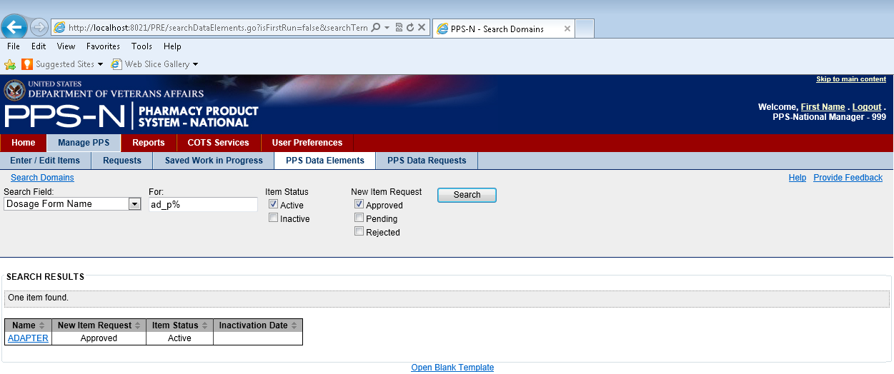

Figure 41: PPS Domain Search Results

1. Select and Review/Edit Domain Item Details

From the search results table, the user will click on the appropriate item link in the “Name” column. This will display the details of the domain item that was chosen. To modify an item, the user then clicks the hyperlink in the “Field Name” column which displays the current value in a pop-up window and allows the user to edit the value if that field is editable.

Note that below the A-Z tab itself, there is a legend which describes three possible attributes that may be displayed in brackets [ ] following the name in the “Field Name” column.

* * – red asterisk indicates a required field which must have a Current Value
* L – local-only field that is not editable by a national manager
* R – read-only field that cannot be edited

In the example shown below, the user performed a Dosage Form search and selected the ADAPTER in the search results table. This displayed the edit page for that domain item, and showed the “A-Z” tab which lists all the related data fields and their current values. Once the user makes any changes in the pop-up window, the user will click the “Save Changes” button which will update the Current Value shown on the page for that domain item. Once the user is done making all changes; then the user will click the “Submit” button to save the changes to the database.

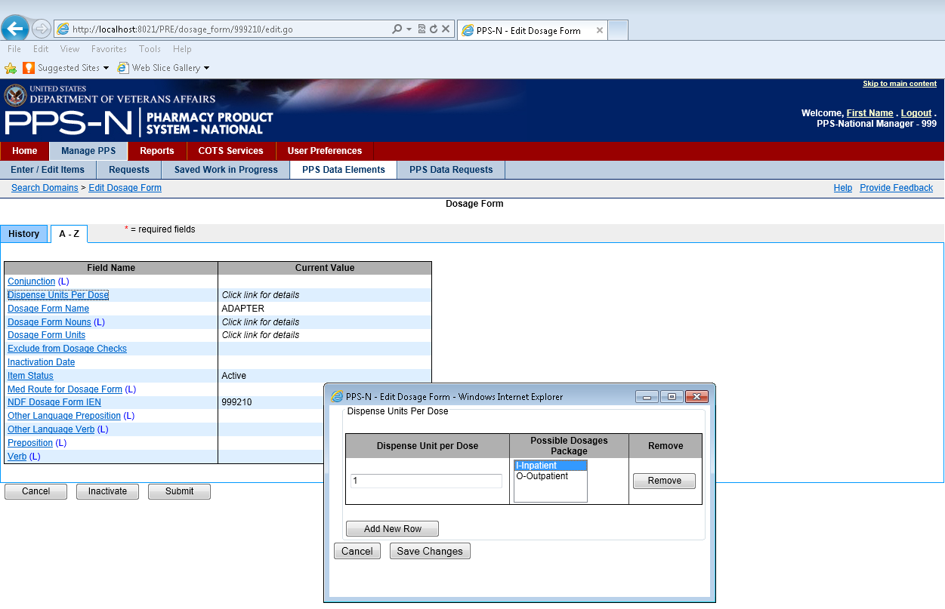

Figure 42: PPS Domain Edit

1. Accept Changes for the Domain Item

When the user clicks the “Submit” button on the domain item page, PPS-N will display a confirmation page that contains a table showing a summary of the changes the user made If the changes are correct, the user will click the “Accept Changes” button and the changes will be saved to the database. If the user needs to undo or modify the change, the user will click the “Cancel” button and PPS-N will return to the previous page.

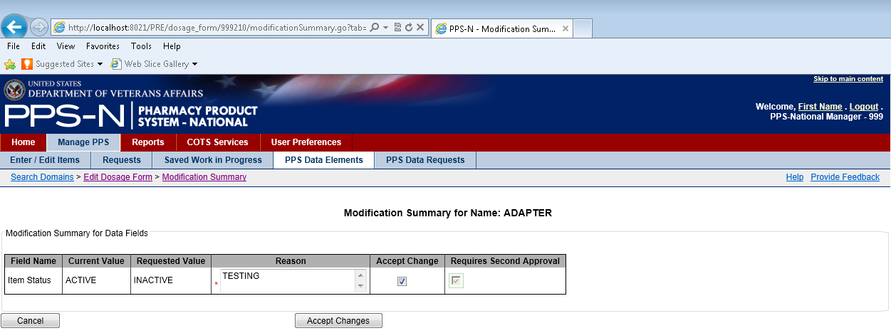

Figure 43: PPS Domain Edit Summary

Error During Domain Item Modification

There will be occasions when PPS-N will display an error message that prevents the modification. As shown below, the user attempted to inactivate a Dosage Form and PPS-N displayed an error message indicating that this change cannot be made because the dosage form is part of active items. In this case, the user will need to cancel the modification and revise the affected items before the domain item can be inactivated.

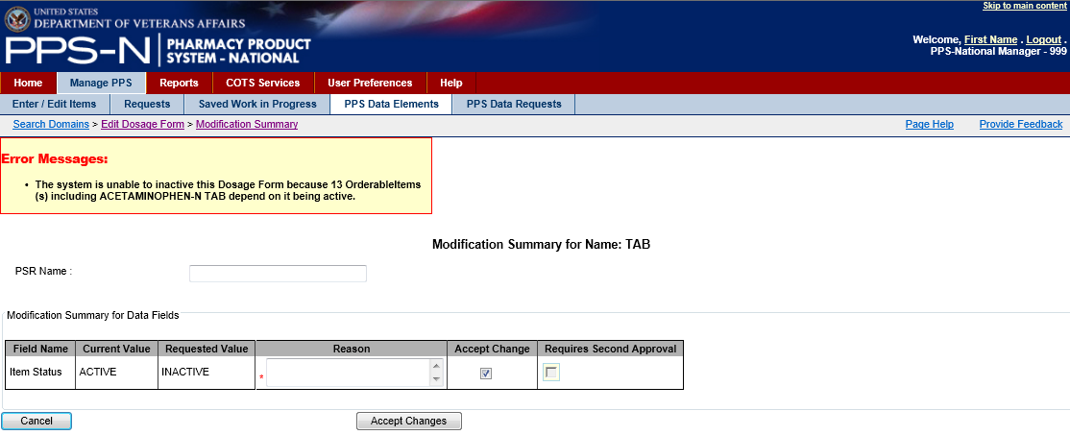

Figure 44: Error Messages

1. Create New Domain Item

If the user searched for a domain item and an appropriate entry was not found, the user could create one using the Open Blank Template link that is found below the search results table, as shown below.



Figure 45: Open Blank Template Link

Each of the domain templates is different Some of very short, while others, like the Dosage Form Name template shown below, have lots of fields that could be completed. When the page appears, the user will complete the relevant fields, and as a minimum all of the required fields (indicated by a red asterisk *).

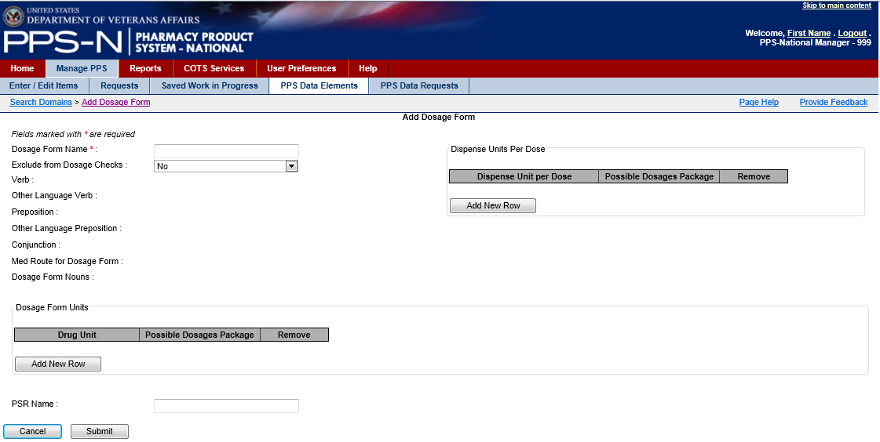

Figure 46: Dosage Form Template

When the user is finished entering the appropriate information for the new domain item, the user will click the “Submit” button and the domain item will be saved to the database.

### PPS Data Requests Tab

Once a new domain item has been created and saved to the database, its approval state is marked as “Pending”, indicating that it needs to be reviewed and approved. This is also the case for some item modifications where the user makes a change to an existing item and that change also requires review and approval. These items are now considered approval requests, and are made available to users with appropriate permissions to approve such requests. To view these “Pending” domain item requests, the user selects the PPS Data Requests tab. As shown below, the items in the ‘Pending’ state are organized in various sub-states so that the user can use these as filters when they perform a search for the pending domain requests.

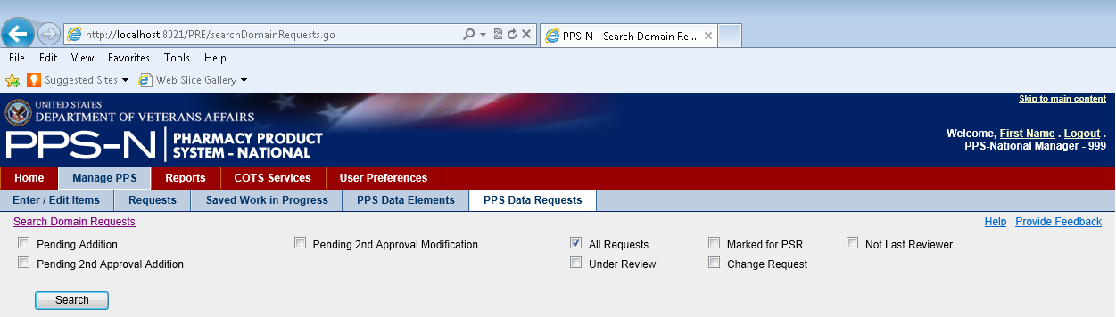

Figure 47: PPS Data (Domain) Requests

1. Select the Appropriate Filter Checkbox(es)

To view the requests, the user will select the appropriate checkbox(es) and then click the “Search” button. Descriptions of the various request type filters (sub-states) are below:

Table 6: Domain Request Type Filters

| **Request Type Filters** |  |
| --- | --- |
| **All Requests** | This is the default check box selection, and it will display all requests that are pending action. |
| **Pending Addition** | Choose this filter to display those pending requests with a Request Type of Addition and a Request Status of Pending Approval. |
| **Pending 2nd Approval Addition** | Choose this filter to display those pending requests with a Request Type of Addition and a Request Status of Pending Second Approval. |
| **Pending 2nd Approval Modification** | Choose this filter to display those pending requests with a Request Type of Modification (an existing item was changed) and a Request Status of Pending Second Approval |
| **Under Review** | Choose this filter to display those requests that were placed Under Review |
| **Marked for PSR** | Choose this filter to display those requests that were Marked for PSR (Peps Second Reviewer). |
| **Change Request** | Choose this filter to display those requests that were marked as a Change Request |
| **Not Last Reviewer** | Choose this filter to display those requests for which you were not the last reviewer, meaning you can approve any of those that are displayed. |

1. Review Domain Requests

When the user clicks the “Search” button on the requests page, PPS-N will display those domain requests that matched the filters. In the example shown below, the user searched for “All Requests” and there was only one in the database. If the search had returned no matches to the filter settings, then PPS-N would have displayed “Nothing found to display” below the table. In that instance, the user should select different filter settings and click the “Search” button again.

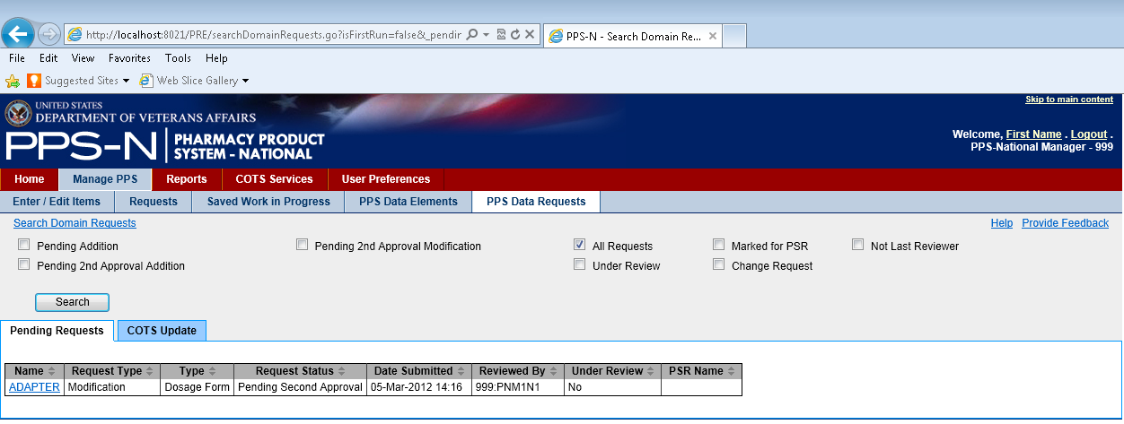

Figure 48: PPS Domains Requests Results

1. Approve Requests

The search results table provides basic information on each request as shown above. As a request, the user will note three relevant columns, “Request Type”, “Request Status”, and “Reviewed By”.

* “Request Type” – Modification (existing item changed) or Addition (new item created)
* “Request Status” – Pending Second Approval
* “Reviewed By” – the name and id of the user that created the item or made the change. This is important to note because a user cannot provide a second approval of an item they changed or created.

The user clicks on the appropriate item link in the first column labeled “Name” When selected, PPS-N will display the addition or modification page for the item chosen, and it is displayed similar to the previously described edit or view pages except that it contains one or more new tabs and some different buttons.

1. Review the Pending Changes

As shown in the figure below, the user will note one or two new tabs added to the domain item view/edit page. For an Addition request, the user will see the “Change Request” tab and it will identify the requester by first name and last name along with any comments they entered. The user will view the item details and then use the new buttons to Approve or Reject the request, or place it Under Review. For a modification request, PPS-N also displays the “Pending Modification” tab which shows the field that was changed, the current and requested values, the requester, and any reasoning provided for the modification. The user will review the changes and then indicate the appropriate response using the dropdown list in the Action column which can be used to mark the proposed change as Approved, Rejected, or Pending. The user will then place the item “Under Review” or click the “Accept Actions” button.

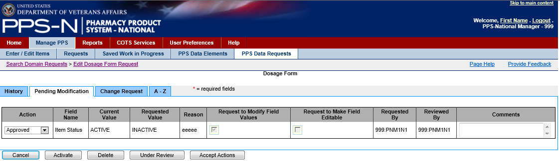

Figure 49: PPS Domain Request Approval

1. Confirm and Approve the Data Request

When the user clicked the “Accept Actions” button, PPS-N presents a confirmation page. After confirming the changes, the user will once again select the “Accept Actions” button as shown below.

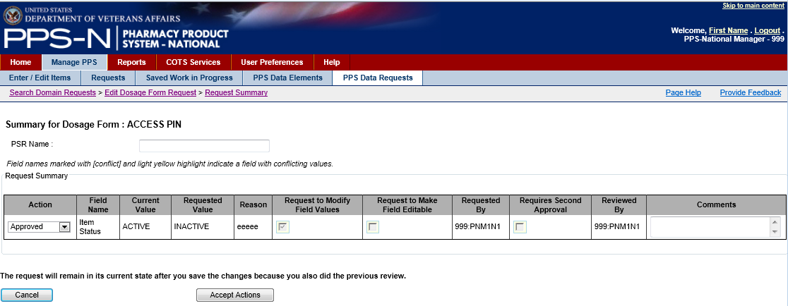

Figure 50: PPS Domain Request Confirmation

PPS-N will now save the modification to the database and return the user to the PPS Data Requests tab.

## Reports Tab

When the user wants to generate reports, the user will select the Reports tab as depicted below.

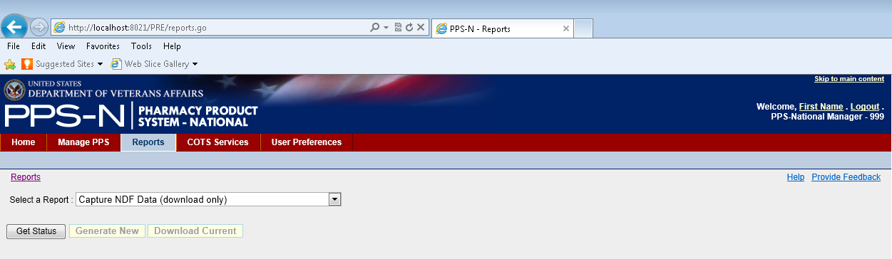

Figure 51: Reports Tab

The user may select a report by clicking the “Select a Report” dropdown list and choosing one of the eight reports listed. Three of these reports include “(download only)” after their name and this indicates that they are generally too large to be viewed on the page and must be downloaded to a file to be viewed.

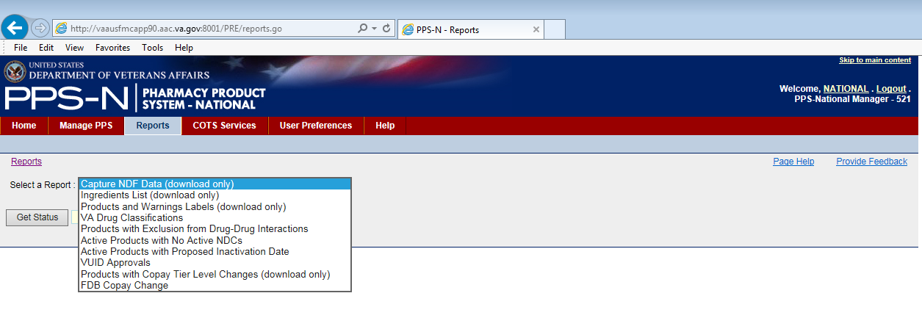

Figure 52: Select Report

The types of reports and their description are shown in the table below. Those that are viewable are further described later.

Table 7: Available Reports

| **Report Type** | **Description** |
| --- | --- |
| **Capture NDF Data\*** | A complete listing of the Active NDCs in PPS-N as well as a large number of their attributes. |
| **Ingredients List\*** | A complete list of the Active products in PPS-N with each of their ingredients. |
| **Products and Warnings Labels\*** | A complete list of the Active products in PPS-N with the warning labels for each product that is retrieved from the FDB Drug Information Framework (DIF). |
| **VA Drug Classifications** | A complete list of the VA Drug Classes displayed in a hierarchical format with the option of including the Description field by choosing the “with Description” Checkbox. |
| **Products with Exclusion from Drug-Drug Interactions** | A list of the products in PPS-N that have had the Drug-Drug Interaction field changes within the time frame chosen. |
| **Active Products with No Active NDCs** | A list of all Active Products in PPS-N that do not have Active NDCs. |
| **Active Products with Proposed Inactivation Date** | A list of all Active Products in PPS-N that have a proposed Inactivation Date. |
| **VUID Approvals** | A list of all the Products, Ingredients, Drug Classes and VA Generics that have been entered into PPS-N, inactivated or reactivated since the start date. |
| **Products with Copay Tier Level Changes\*** | A list of Products, active, inactive, or both, in the PPS-N EPL whose Copay Tier Level was modified since the start date. |
| **FDB Copay Change Report** | A list of the Products in the PPS-N EPL that have a current Copay Tier Level of 3 but FDB data indicates they should be changed to Copay Tier Level 2; products with a current Copay Tier Level of 3 whose PPS-N GCNSEQNO does not find a match in FDB; and products with a current Copay Tier Level of 3 whose PPS-N GCNSEQNO does find a match in FDB, but all associated FDB NDCS are obsolete. Optionally, products that are inactive or have no GCNSEQNO can be selected to display on the report. |

Note: Report types marked with an asterisk (*) are downloadable only. These reports will not be displayed on the screen due to its length.

### How to Use the Buttons

Reports – “Get Status” Button

The download-only reports include a “Get Status” button which will retrieve the current report statistics from the database when selected. This information will indicate the last time a report was generated, and when the process Started and Completed. If a report is currently being generated, and the user clicks the “Get Status” button, then the Process Status will indicate that it is Running, the “Generate New” and “Download Current” buttons will be grayed out, and the Completed date will not be filled in.

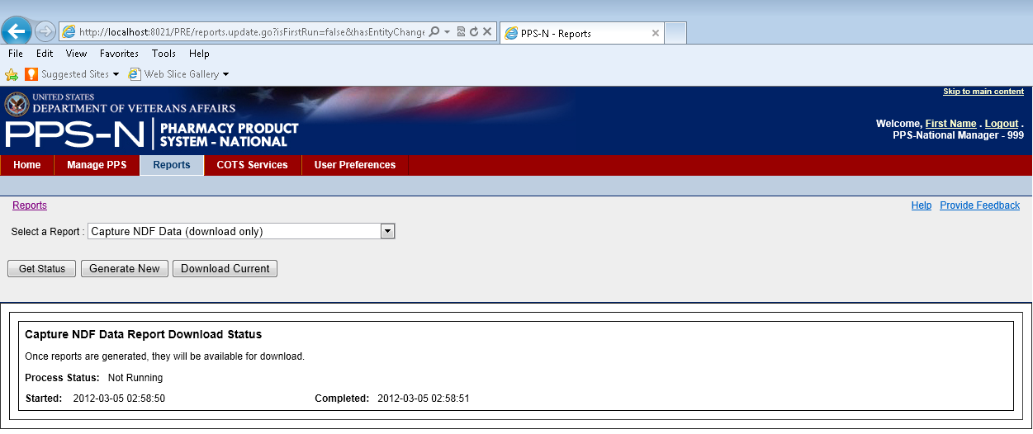

Figure 53: Report Status

Reports – “Generate New” Button

The download-only reports also include a “Generate New” button which can be selected to create a new report. After selecting the previously described “Get Status” button, PPS-N will activate this button so it can be selected. When the user clicks the “Generate New” button, a pop-up window will be displayed with a message indicating how long the process will take (see below). Once the user clicks the “OK” button, the process will begin.

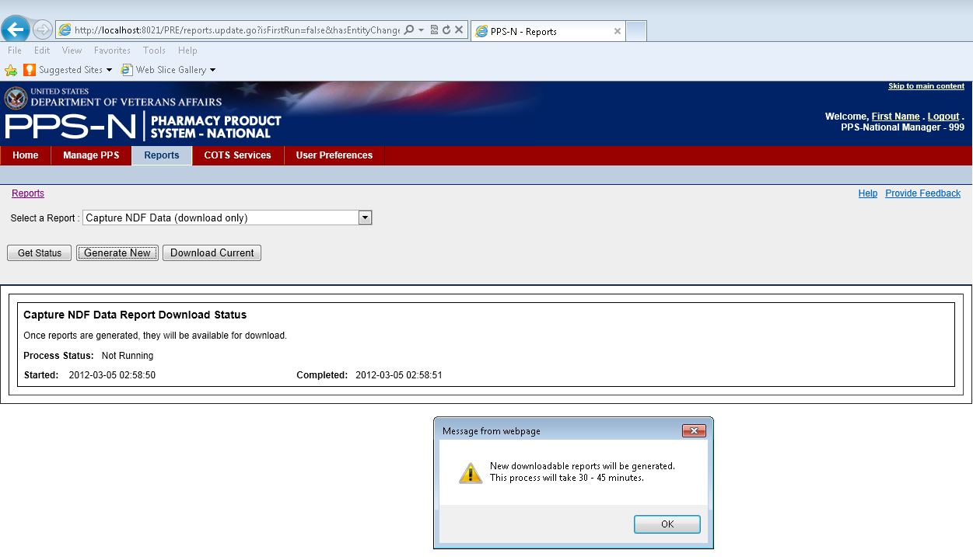

Figure 54: Report Generate New

Reports – “Download Current” Button

All of the report pages include a “Download Current” button. When selected, a dialog will be displayed as shown below allowing the user to Open or Save the report, or Cancel the request. The report uses the comma-separated value(.CSV) format and the user can view them via a third party tool such as Microsoft Excel.

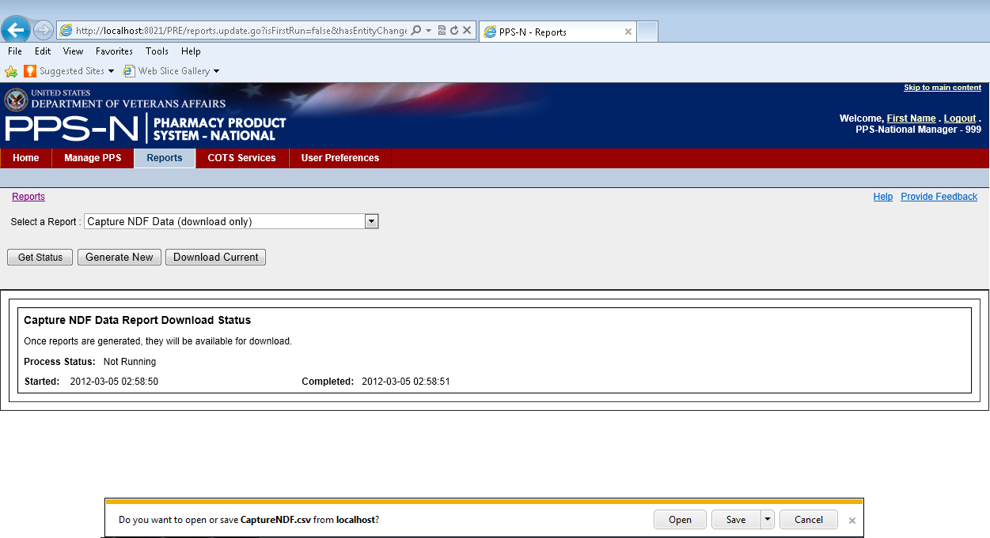

Figure 55: Report Download

Reports – “Run Report” Button

For all the reports that are not download only, the user will have a choice to save or view the most recent generated report or to run a new report. For the latter, the user will select the “Run Report” button, and the results will be displayed on the same page. With this option, the user can also select a date range using the “Start Date” and “Stop Date” fields as shown below.

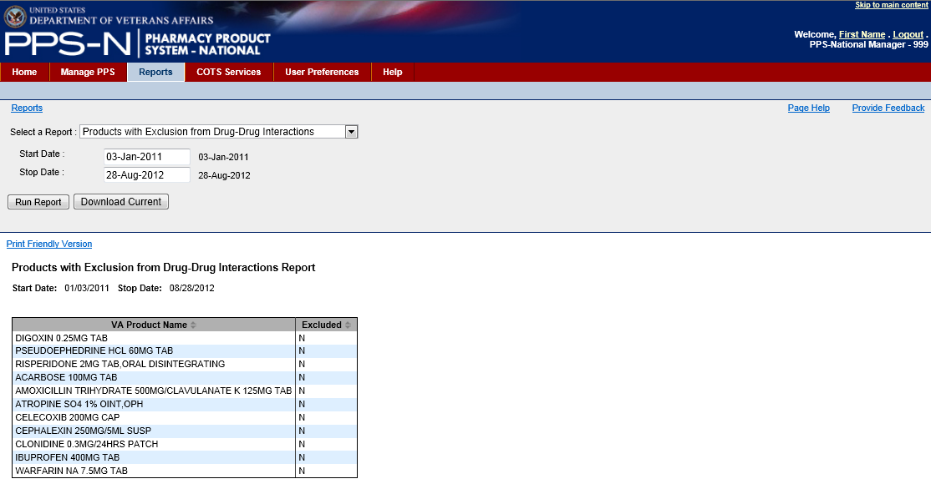

Figure 56: Run Reports with Date-Time Range

### Types of Displayable Reports

The user will select the appropriate displayable report using the dropdown list.

1. Report – VA Drug Classifications

The VA Drug Classifications Report shown below is a listing of all the VA Drug Classes in the system. The user can optionally display the descriptions if desired by clicking the “with Description” checkbox.

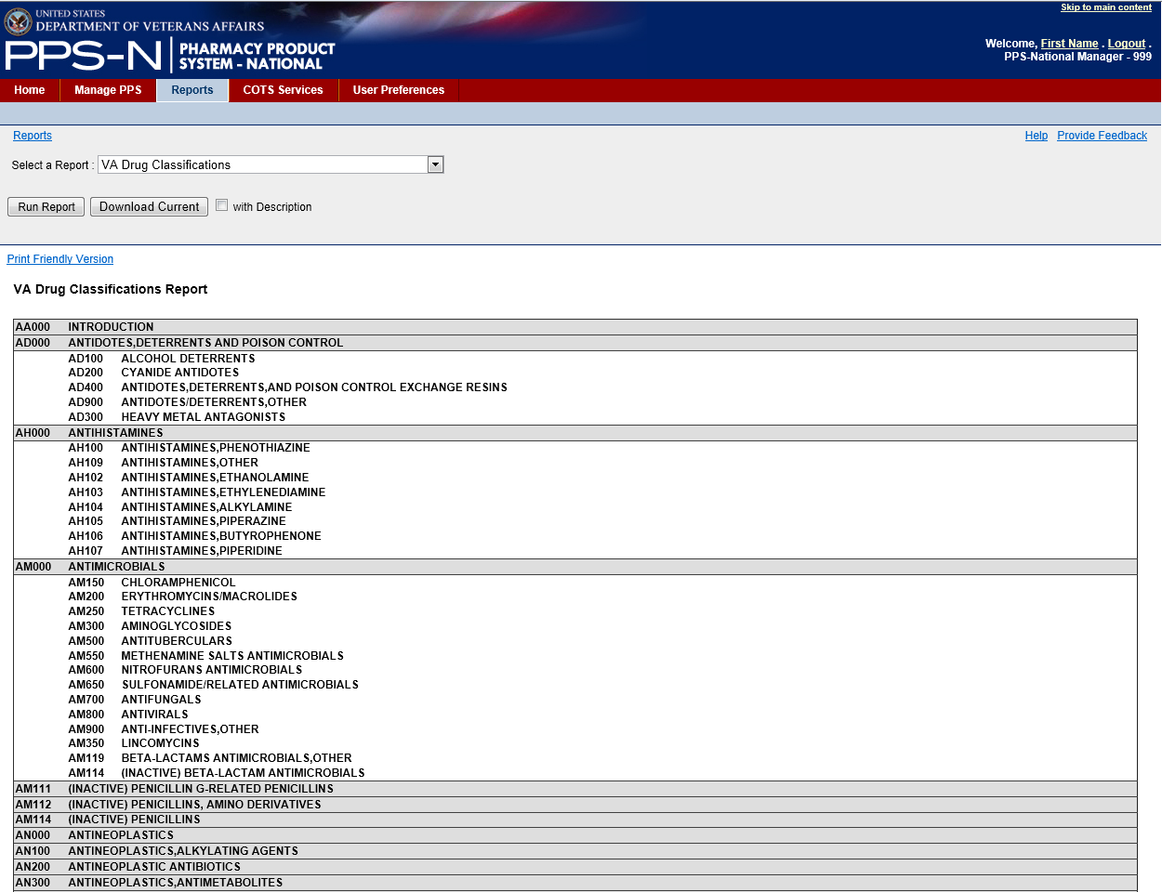

Figure 57: VA Drug Classifications Report

1. Report – Products with Exclusion from Drug-Drug Interactions

The Products with Exclusion from Drug-Drug Interactions Report shows all the products that have been created in PPS-N (during the start and stop dates time period) and shows the VA Product Name and a letter indicating whether or not the product is marked for exclusion – N for No and Y for Yes.

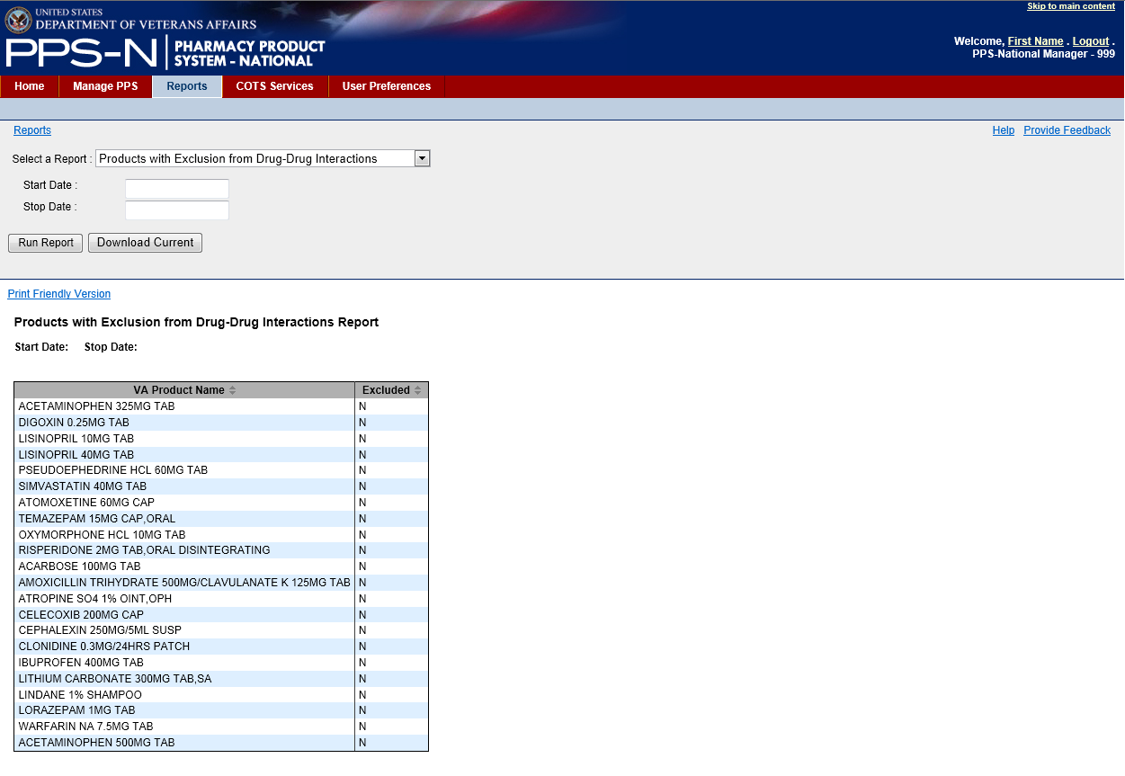

Figure 58: Exclude from DDI Report

1. Report – Active Products with No Active NDCs

As shown below, the Active Products with No Active NDCs Report list all the Active Products in PPS-N that do not have any active NDCs. The user may elect to view the products by selecting the hyperlinked VA Product Name.

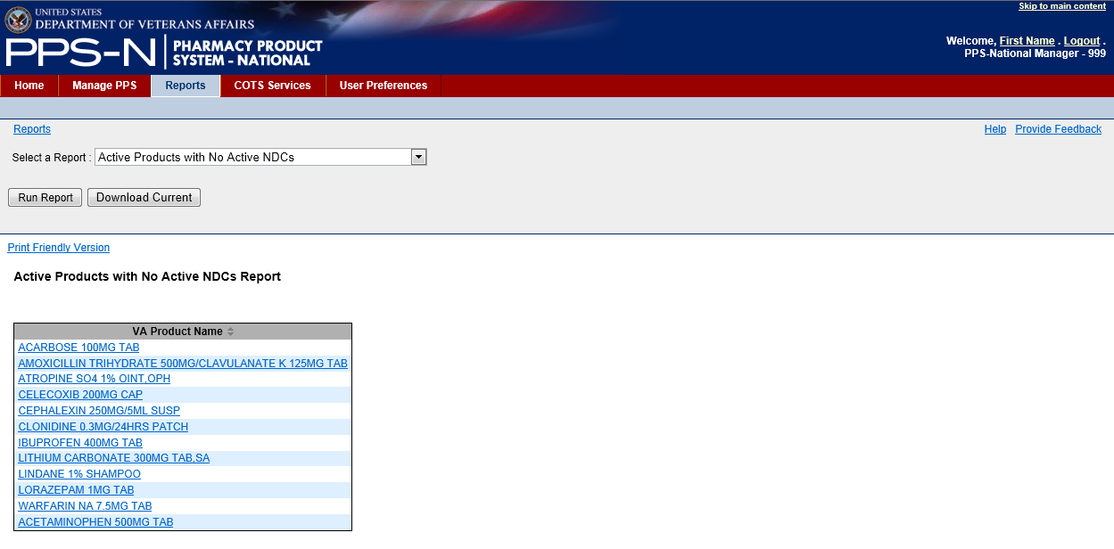

Figure 59: No Active NDCs Report

1. Report – Active Products with Proposed Inactivation Date

The Active Products with Proposed Inactivation Date Report shown below is a listing of all the active products in PPS-N that have a “Proposed Inactivation Date”. Optionally, the user may select a Start Date to filter the results from the start date to the current date.

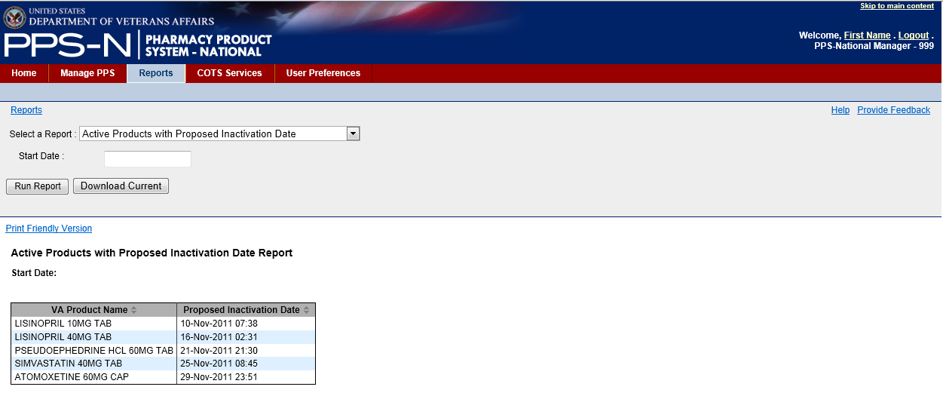

Figure 60: Proposed Inactivation Date Report

1. Report – VUID Approvals

The VUID Approvals Report shows all products, ingredients, generic names, and drug classes that have been approved, inactivated or reactivated in PPS-N. Before running this report, the user must enter a Start Date or else no results will be displayed.

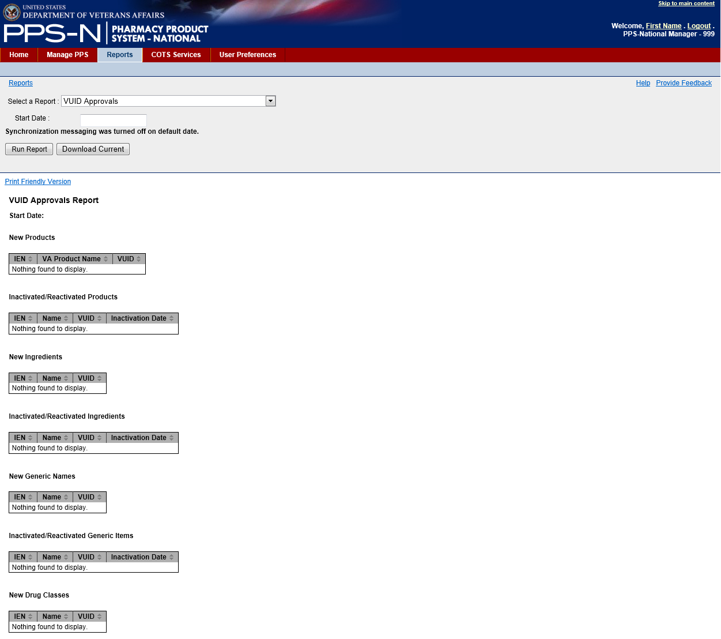

Figure 61: VUID Approvals Report

1. Report – FDB Copay Change Report

The VUID Approvals Report shows all products in PPS-N defined with a current Copay Tier Level of 2, but the FDB product with the same GCNSEQNO indicates that the Copay Tier Level should be 3. The user may elect to edit the product’s Copay Tier Level by selecting the hyperlinked VA Product Name. Optionally, the user may select to display inactive products, products with no GCNSEQNO, and products whose corresponding FDB product has a federallegendcode value that is neither O nor F.

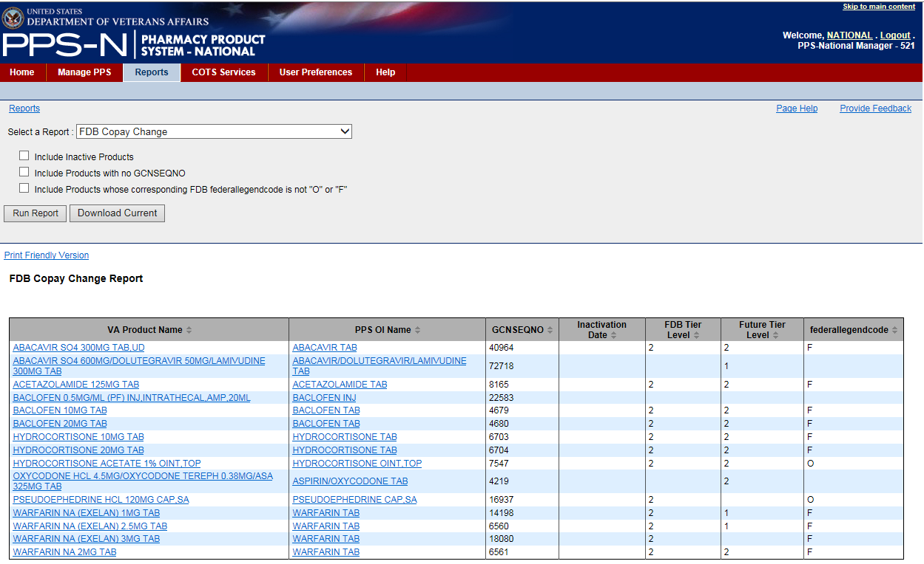

Figure 62: FDB Copay Change Report

### COTS Services Tab

The user may perform a number of operations dealing with the FDB Drug Information Network through the COTS Services tab.

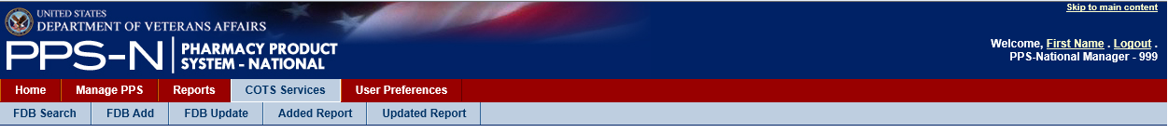

Figure 63: COTS Services Tab

As shown above, these services include:

* FDB Search – search the FDB database for drug information
* FDB Add – FDB packaged drugs that were added to FDB but not automatically added to PPS-N during the last scheduled FDB Add process
* FDB Update – FDB items that were updated in FDB but not updated in PPS-N during the last scheduled FDB Update process
* Added Report – FDB items that were automatically added to PPS-N during the last scheduled FDB Add process
* Updated Report – FDB items that were automatically updated in PPS-N during the last scheduled FDB Update process

Each of these COTS services is further explained on subsequent pages.

### FDB Search Tab

The user can search the FDB database using the query capability on the FDB Search tab as shown below.

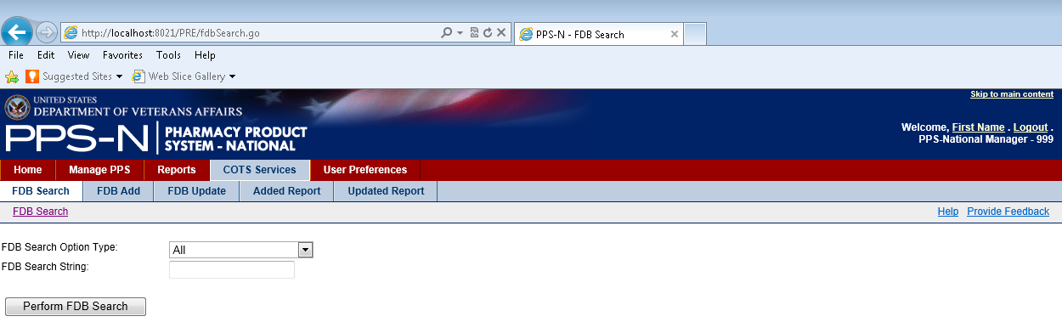

Figure 64: FDB Search Tab

1. FDB Search Parameters

The user will first select the type of search using the “FDB Search Option Type” dropdown list which contains All, NDC, Label, Generic, GCNSEQNO, and Drug Class. These are explained in the table below.

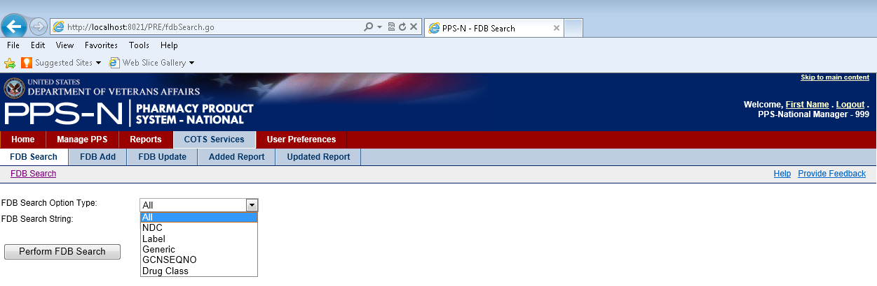

Figure 65: FDB Search Options Type

Table 8: FDB Search Option Types

| **Search Option Type** | **Description** |
| --- | --- |
| **NDC** National Drug Code | The user will need to enter at least 5 digits and the system will search the first five digits of the 11-digit NDC number of the FDB Packaged Drug. |
| **Label** | The text entered will be used to search the FDB Label Name Field. |
| **Generic** | The text entered will be used to search the FDB Generic Drug Name Field. |
| **GcnSeqNo** | The GCN Generic Code Number Sequence Number must be a numeric value that corresponds to the GCN Sequence Number of an FDB Generic Drug. |
| **Drug Classifications** | The text entered will be used to search the FDB Drug Class The grouping of drug products based on various criteria, which may include similarity of chemical structure, clinical indications, pharmacology, and therapeutic activity. fields for both the FDB Generic and the FDB Dispensable Drug. |
| **All** | The All search will search each of the above searches and aggregate the results. |

The user will then enter the appropriate text in the “FDB Search String” textbox and click the “Perform FDB Search” button. Note that the normal PPS-N data entry validation rules apply for NDC (numeric and correct format) and GCNSEQNO (numeric only) and PPS-N will display an Error Message if the textbox entry does not comply with the rules.

1. FDB Search Results

The FDB search results table shows the FDB Packaged Drugs that match the search criteria in the search that was performed. In the example shown below, 477 items matched the search results for the NDC string ‘00067’ and the first ten results were displayed. Note that the results are limited to the first 501 items that match the query.

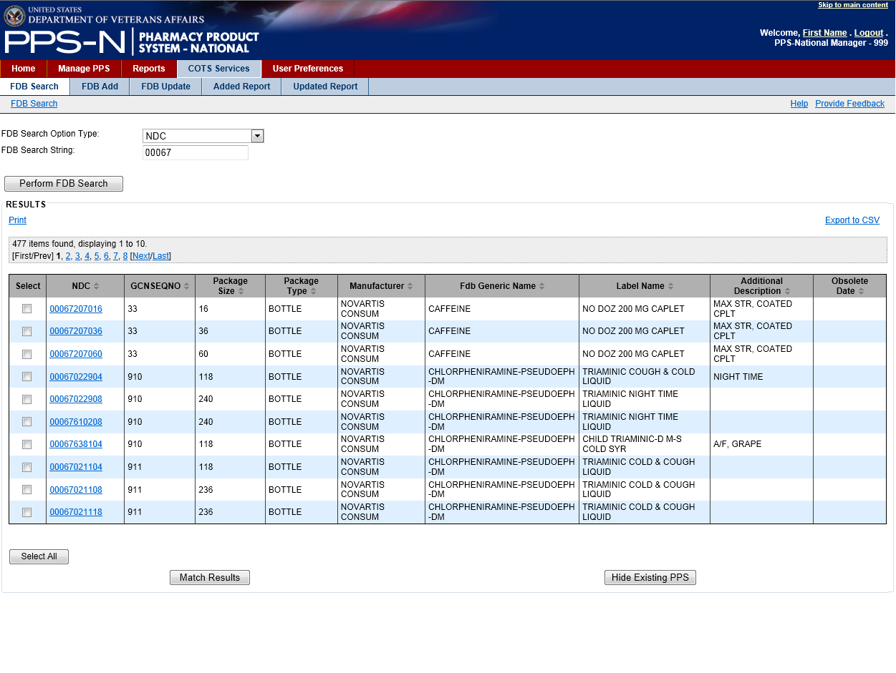

Figure 66: FDB Search Results

Also note that there are links on the left and right hand side above the search results table that permit the user to Print or Export to CSV, respectively, all of the items in the search results table.

1. FDB Search – Review NDC Details

The user may click on the hyperlink in the NDC column of the search results to view the Details page for a particular FDB Packaged Drug. This information is displayed directly from the FDB database.

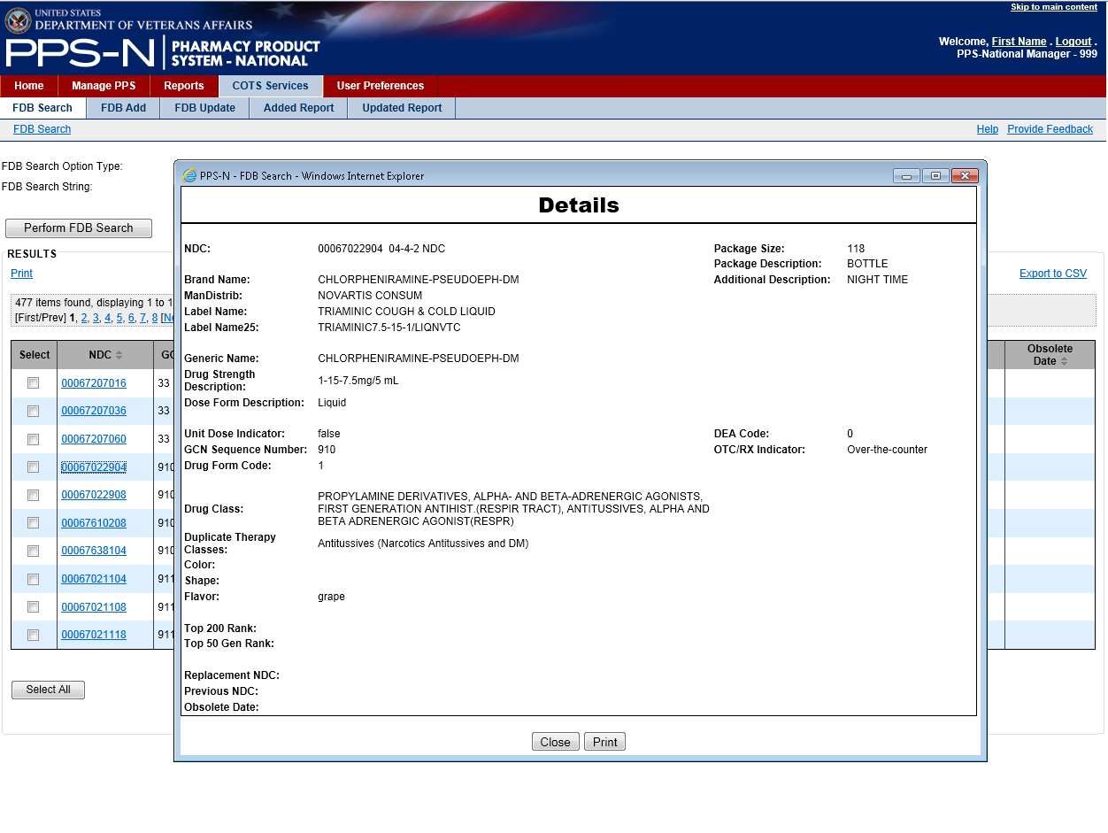

Figure 67: FDB Item Details

1. FDB Search – “Match Results”

Below the search results table is a “Match Results” button. Selecting this button will start a process whereby the selected NDCs are matched to existing items in PPS-N with the same GCN sequence Number (GCNSEQNO column). To use this process, the user will select one or more NDCs in this list and then click the “Match Results” button. Note that the selected NDCs must all have the same GCNSEQNO or PPS-N will generate an Error Message.

There are also two other buttons the user may use. The “Select All” button will mark (check) all of the checkboxes in the Select column of the table. The “Hide Existing PPS” button will compare all of the NDCs in the search results table and remove those that match NDCs that are already present in PPS-N.

When the user selects the “Match Results” button, PPS-N redirects to the matching page, copies the selected NDC items into the FDB NDCs table on the left half of the page, and displays on the right half of the page any products in PPS-N that matched the GCNSEQNO. At this point, the user has the following options available on this page:.

* “Blank Template” button –There are no products suitable as a parent for the selected NDCs so access a blank product template. When the user completes the form and submits the product, associate the NDCs with the product and then save the NDCs to the PPS-N database.
* “Add to Product” button – The user will first select the appropriate product from the VA Products list in the table. Once the button is selected, associate the selected NDCs to the product and save them to the PPS-N database.
* “Use Existing” button – The user will first select a product from the VA Products list in the table. This product will be used as a template to create a new product that will serve as the parent for the selected NDCs. Once the button is selected, create a template using the selected product. When the user makes the desired changes, save the product to the database, associate the NDCs to the new product, and save the NDCs to the database.
* “Product Search” button – No products matched the selected NDCs. When the user selects this button, PPS-N displays the product (parent) search page. The user searches for an appropriate product and selects it from the search results. The previous matching page is displayed again, and the VA Products table now shows the selected product. The user can now select the radio button for that product, and then use one of the other buttons to continue the NDC assignment process.
* “Cancel” button - Return to the FDB search page.

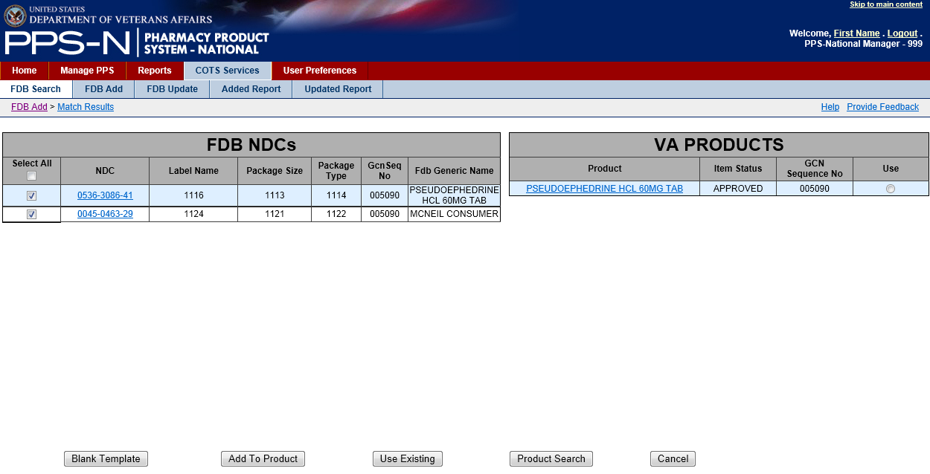

Figure 68: FDB Match Results

### FDB Add Tab

The FDB DIF is updated on a periodic basis. A background task runs periodically within PPS-N to query the FDB database, identify new products that have been added to FDB since the last scheduled run, and then add the new products to PPS-N.

The FDB Add tab displays FDB Packaged Drugs that were not automatically added during the most recent scheduled FDB Add process. They are displayed in a results table.

The user has two options from this tab. The user can select items and click the “Match Results” button which will redirect PPS-N to the matching process page, add the selected NDCs to the FDB NDCs page, and show any potentially associated products. The rest of the process will be performed using the instructions in the previous section. A second option allows the user to use the “Delete” button to remove selected NDCs from the FDB Add results table..

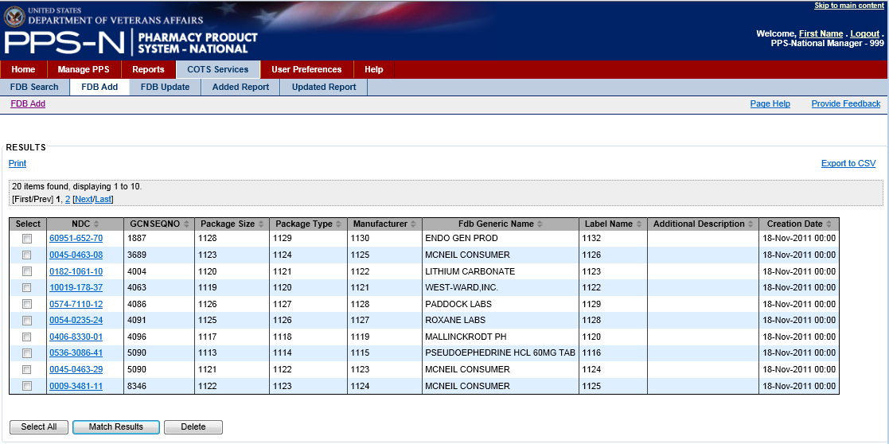

Figure 69: FDB Add

### 

### FDB Update Tab

The FDB DIF is updated on a periodic basis. A background task runs periodically within PPS-N to query the FDB database and identify products that have been updated in FDB since the last scheduled run, and then add certain product updates to PPS-N.

The FDB Update Tab contains a results table showing the FDB items that were updated (modified) in FDB but not automatically updated in PPS-N because they did not match specifically-defined update criteria.

The user can select an NDC link and view an item, and they can also check the checkbox for one or more items and delete them from the list. If the user does not delete them, they remain on the list for 90 days.

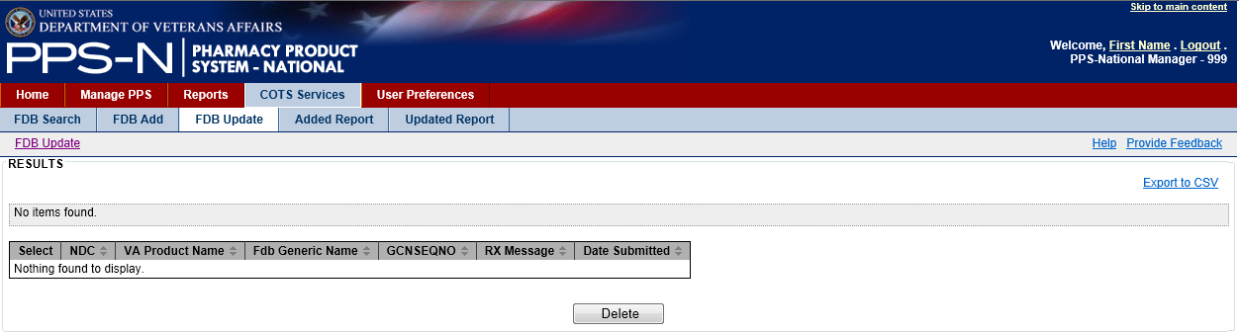

Figure 70: FDB Update

### 

### (FDB) Added Report Tab

The FDB Added Report presents a list of FDB items that were automatically added to PPS-N during the last scheduled process.

The user can select an NDC link and view an item, and they can also check the checkbox for one or more items and delete them from the list. If the user does not delete them, they remain on the list for 90 days.

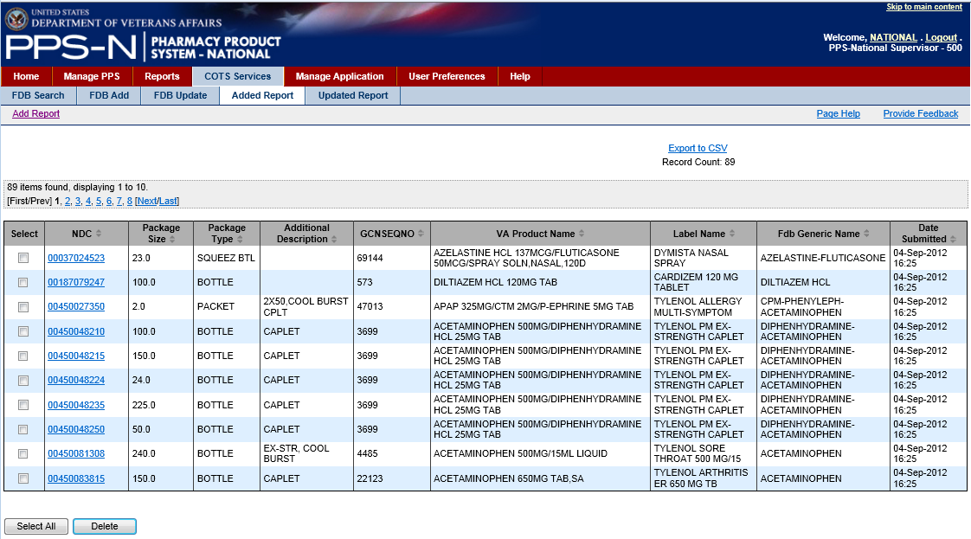

Figure 71: FDB Added Report

### (FDB) Updated Report Tab

The FDB Updated Report presents a list of FDB items that were automatically updated (modified) in PPS-N during the last scheduled process. The results table looks the same as that previously shown for FDB Update.

The user can select an NDC link and view an item, and they can also check the checkbox for one or more items and delete them from the list. If the user does not delete them, they remain on the list for 90 days.

### 

### User Preferences Tab

The user may set a number of display and formatting preferences to personalize their PPS-N experience through the User Preferences tab.

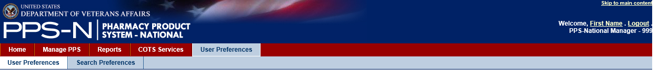

Figure 72: User Preferences Tab

This tab provides two sets of preferences:

* User Preferences – set the default login page, date-time format, number of table rows to display, and a variety of FDB search filter settings.
* Search Preferences – define the layout of the search results tables when performing an “All Fields” search on NDCs, products and orderable items.

### 

### User Preferences Tab

The User Preferences tab contains a variety of preferences that the user can set to personalize their PPS-N displays. These include settings for Date and Time formats, the default login page, the number of rows to display in the tables, and FDB filters and search formats. Each of these is shown in the figure below.

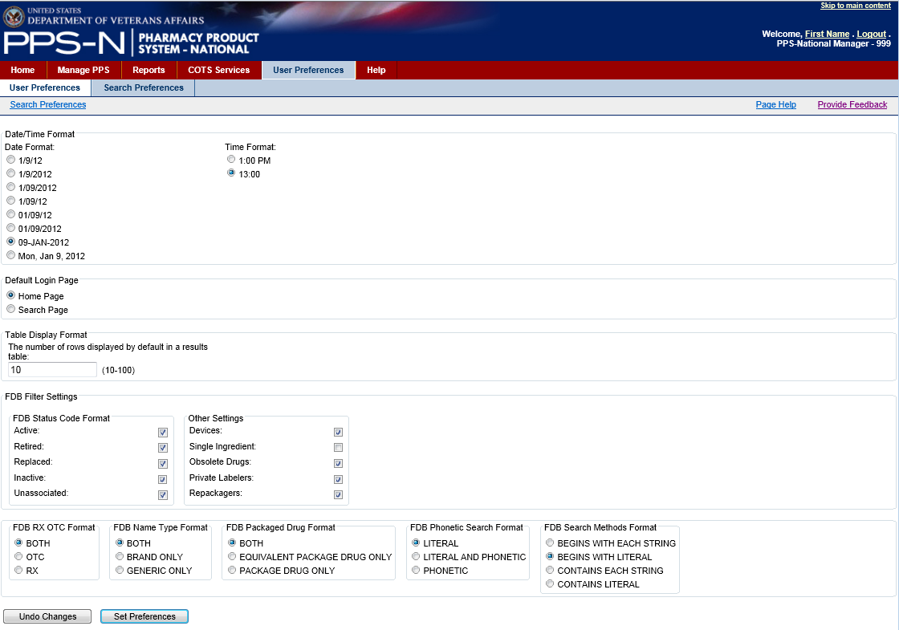

Figure 73: User Preferences

The user will select the various preferences and filter settings and then click the “Set Preferences” button to save the preferences to the PPS-N database. If the user starts making selections and doesn’t want to save them, the user will click the “Undo Changes” button.

### Search Preferences Tab

The Search Preferences tab allows the users to create the results templates for the “All Fields” search in the simple search page (under Manage PPS).

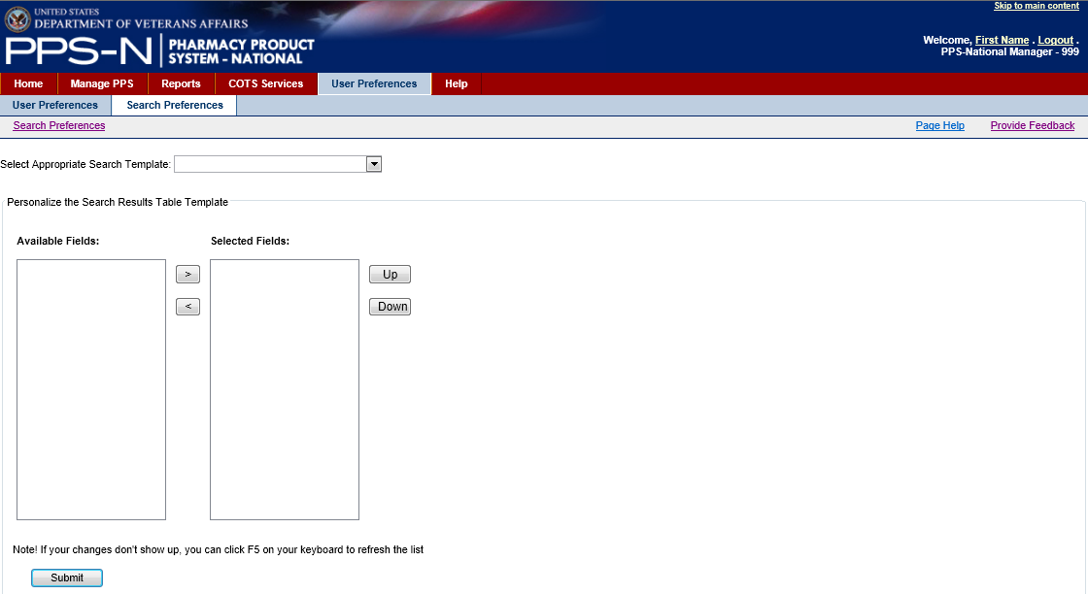

Figure 74: Search Preferences

1. Search Preferences – Search Templates

There are three types of personal search templates: Product, Orderable Item and NDC. This corresponds to the Item Types that can be selected when performing searches.

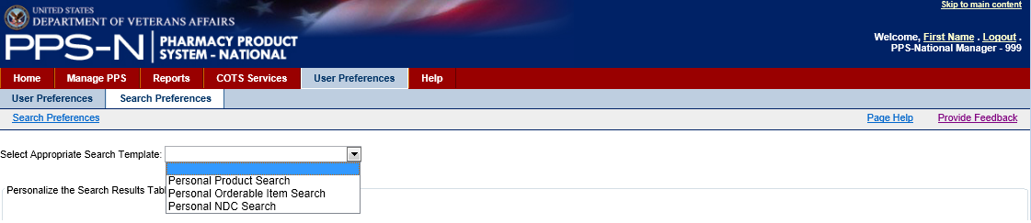

Figure 75: Search Templates

The user will select the type of search template that they want to personalize from the Select Appropriate Search Template dropdown list as shown above.

1. Search Preferences – Available Fields

When the user selects a personal search template type, the Search Results Table Template will be automatically loaded.

If this is the first time that the user is creating the template, the Available Fields panel on the left side will contain all of the fields available for selection and display, and the Selected Fields panel will be empty, as shown below.

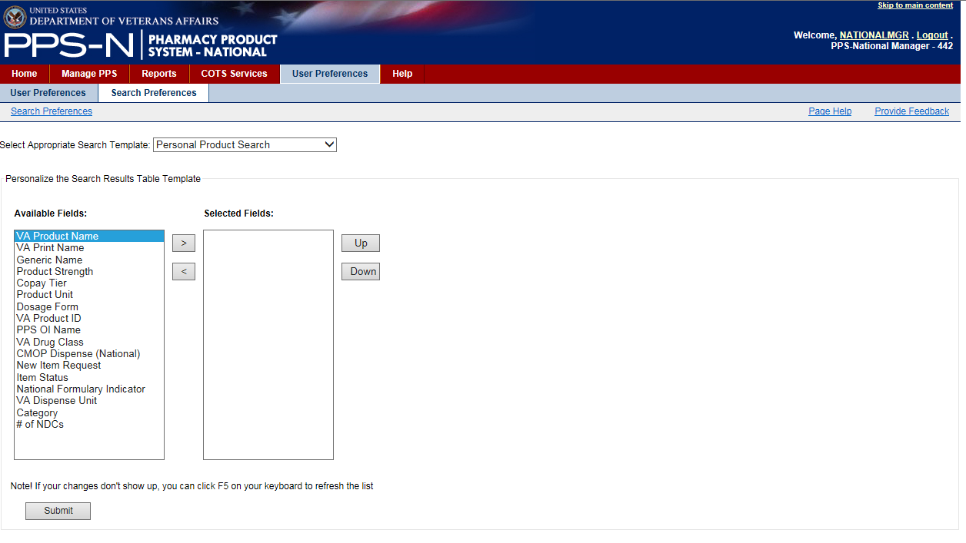

Figure 76: Edit Search Template

The user will highlight the items in the Available Fields panel that they want to include in their search results and use the right “>” button to move the item(s) to the Selected Fields panel. If needed, the user may move an item back to the Available Fields panel using the left “<” button.

The user may also define the order of the items in the Selected Fields panel by selecting an item and then using the “Up” and “Down” buttons. This order, top to bottom, is how the search results will be displayed in the All Fields search results table (left to right).

Once the user is satisfied with the items in the Selected Fields panel, the user will click the “Submit” button to save the changes.

An example of a Personal Product Search template with four selected fields is shown below.

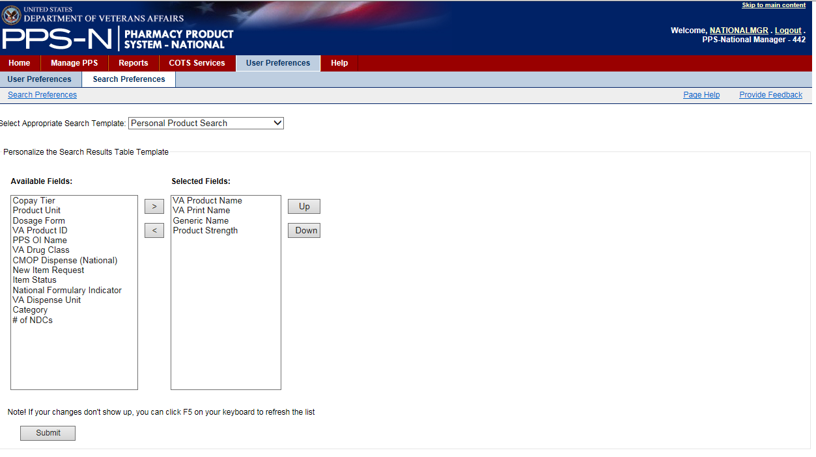

Figure 77: Selected Fields for Product Search Template

1. All Fields Search Results Using Personalized Product Search Template

The image below shows an example of the “All Fields” product search based on the template that was created during the last step above.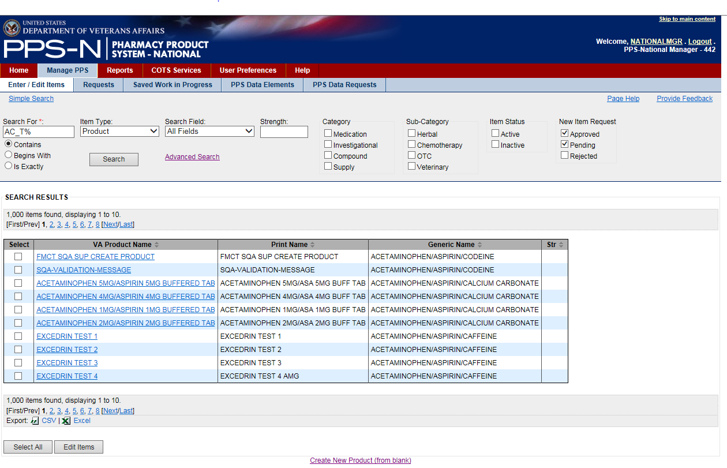

Figure 78: Simple 'All Fields' Product Search

## Help Tab

The user may access the Help files one of two ways. For general help in learning about PPS-N, the user will select the Help Tab.

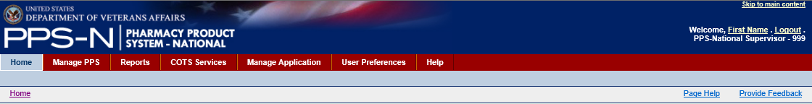

Figure 79: Help Tab

Selecting the Help tab launches the PPS-N Help application which is built using RoboHelp. The main help page is shown below.

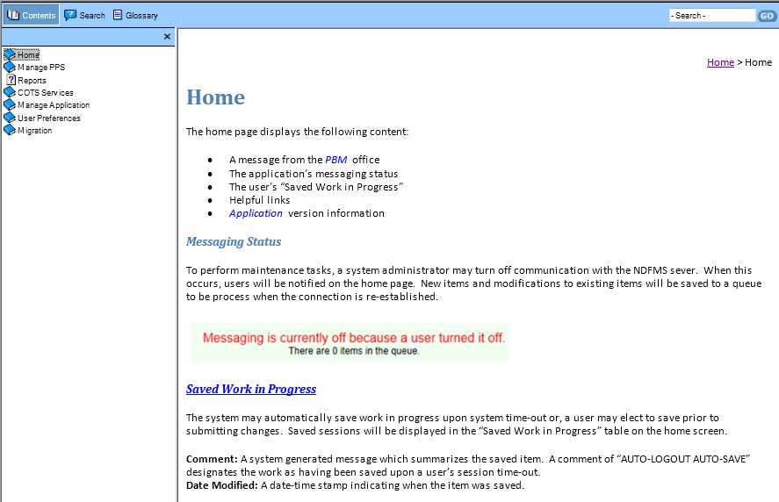

Figure 80: Main Help Page

The top menu bar has three selectable options on the left and then a search box on the right. The three left options include the following:

* Contents – organized in folders based on the main menu items within PPS-N
* Search – enter text to search for, along with options for highlighting search results and defining how many results to display per page
* Glossary – a list of terms and acronyms along with their definitions.

Images of these three options, Contents, Search, and Glossary, are shown below.

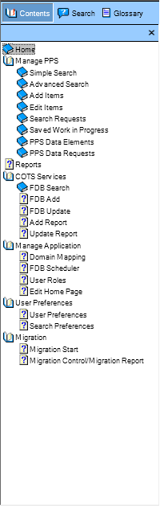 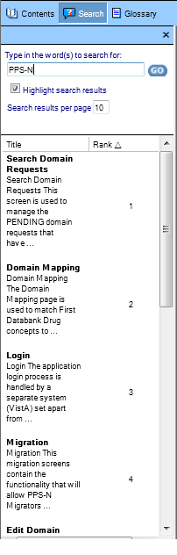 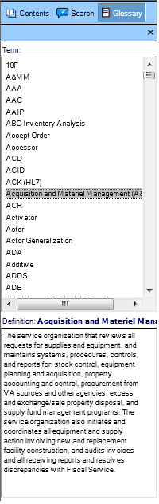

Figure 81: Help Options

Additionally, PPS-N provides page-level, context-sensitive help. When the user has a question about using a specific page within PPS-N, the user can select the Page Help link as shown below.

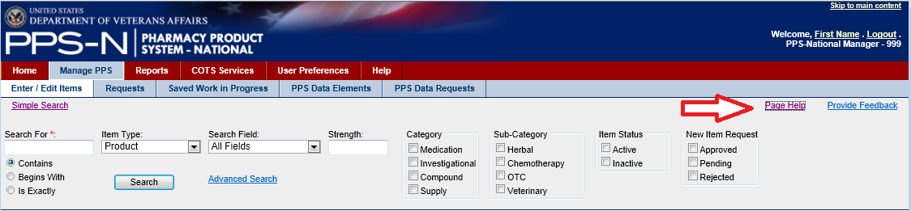

Figure 82: Page Help

When the user clicks the Page Help link, the RoboHelp application will launch and display the appropriate content based on the page. As an example, when the user selected the Page Help link shown above, the following Simple Search window will appear.

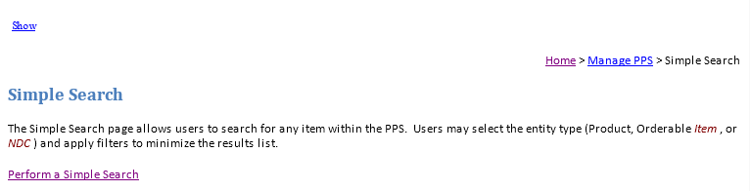

Figure 83: Context-Sensitive Page Help

If the user clicks the Show link in the upper left of the window, the panel with the three options described above will appear.

The user may use the breadcrumb navigational path shown in the upper right to visit the Home or Manage PPS Tab pages.

The user may also use links within the text to navigate to related pages, such as Perform a Simple Search which is shown in the lower portion of the figure above.

## Manage Application Tab – for Supervisor Roles Only

Users who have a Supervisor Role will also have access to one other tab, Manage Application, as shown below.

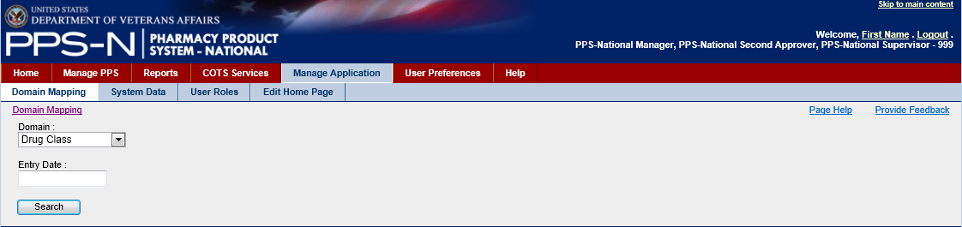

Figure 84: Manage Application Tab

This tab provides access to four other tabs:

* Domain Mapping – associate PPS-N terms with FDB terms
* System Data – the FDB Control Process panel which allows for scheduling of various PPS-N tasks
* User Roles – define roles and respective access permissions to various PPS-N users
* Edit Home Page – use a form to edit the Home page content

Each of these is described on subsequent pages.

### Domain Mapping Tab – for Supervisor Roles Only

The user may select the Domain Mapping tab to associate (map) PPS-N terms to FDB terms.

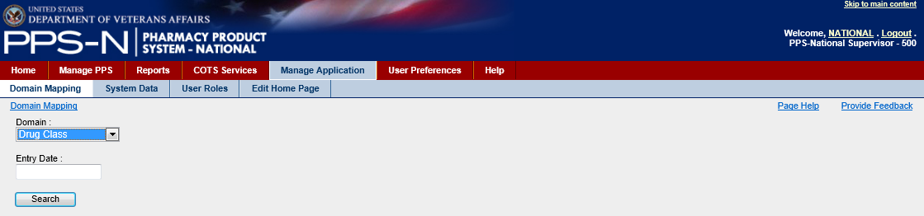

Figure 85: Domain Mapping Tab

The user will first select one of the options in the Domain dropdown list as shown below. The user also has the option to enter an Entry Date which will filter the results beginning with that date to the present.

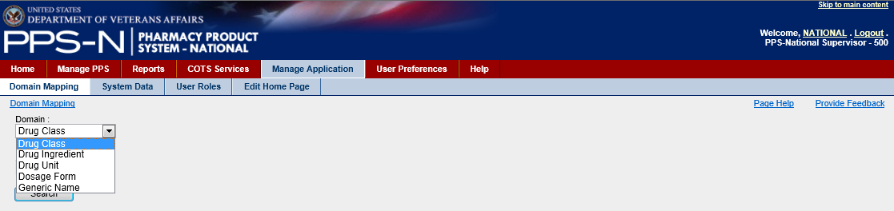

Figure 86: Domains for Domain Mapping

Regardless of the Domain selected, the results tables all use the same presentation format as shown below:

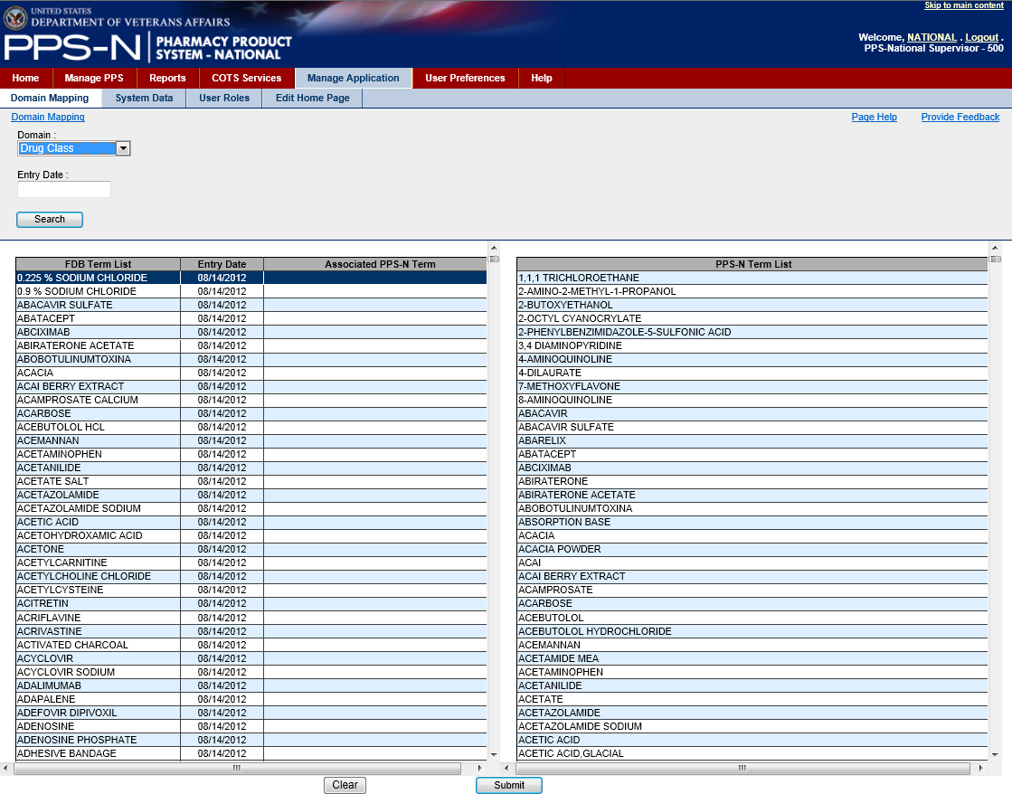

Figure 87: Domain Mapping Tables

The table on the left shows the FDB terms, their entry date, and any associated PPS-N term from the table on the right. To make an association, the user will click the appropriate FDB term in the list on the left and then click the associated PPS-N term in the table on the right.

The item selected in the right-hand table will then appear in the Associated PPS-N Term column in the left-hand table as shown below.

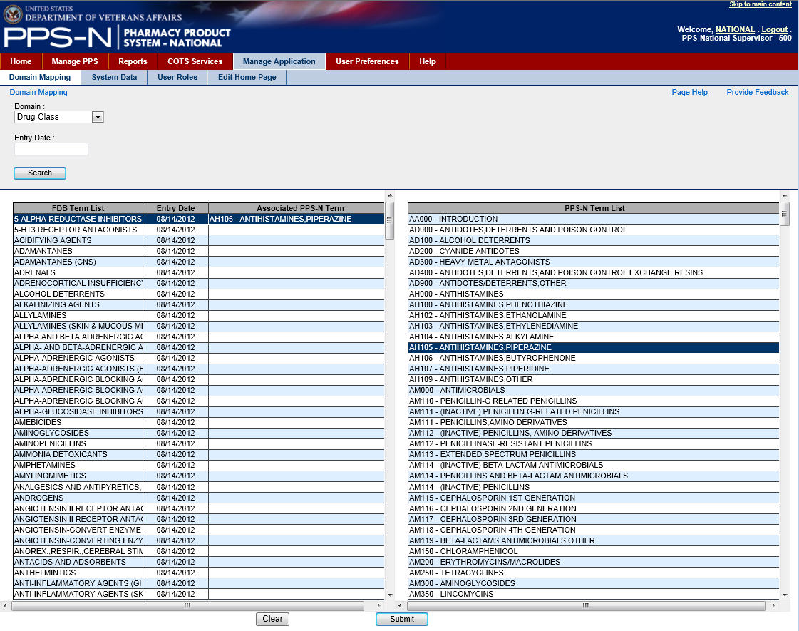

Figure 88: Domain Mapping Assignments

If the user decides that an association is wrong, while the left-hand item is selected, the user may either select a new item in the right-hand table, or the user may click the “Clear” button. When the user is finished making the associations, the user will click the “Submit” button.

### System Data Tab – for Supervisor Roles Only

The user may select the System Data tab to manage the FDB control processes. This is also referred to as the FDB Scheduler.

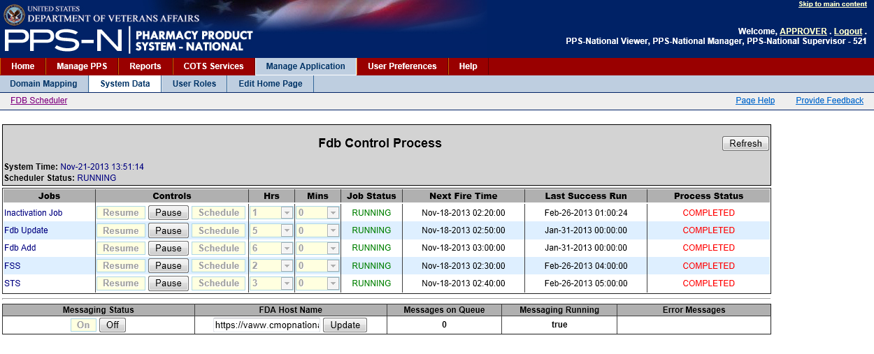

Figure 89: System Data Tab

The FDB Control Process panel manages the FDB Scheduler process which is used to schedule when the five PPS-N background tasks will be executed. Each of these tasks executes independently. For performance reasons the tasks should be scheduled to run at night when PPS-N is not being used, and the tasks should be spaced out so they do not run at the same time. Generally each task will run in less than five minutes so they don’t need to be scheduled hours apart..

Information on the five tasks is presented in the following table..

Table 9: FDB Control Process Jobs

| **Jobs** | **Description** |
| --- | --- |
| **Inactivation Job** | This job looks at the Product and *NDC* National Drug Code proposed inactivation dates. If there are any NDCs that are Active and have a proposed Inactivation Date earlier than the current date then the NDC will be inactivated. If there are any Products that are Active and have a proposed Inactivation date earlier than the current date then a Request A user action that a PEPS Item (OI, Product Item, or NDC Item) addition or modification be considered by the PNM for updates within the PEPS enterprise database. to Inactivate the product will be put on the request list. |
| **FDB Update** | This job will search the FDB Packaged Drugs Update Date field for all entries greater that the Last Successful Run date. When a match is found, the system will check the FDB Drug against its VA Department of Veterans Affairs equivalent to see if any fields that are currently monitored by the VA were updated. If so, then the job will put an entry on either the FDB Update list (if the system could not automatically process the update) or the Update Report (if the system automatically processed the update. |
| **FDB Add** | This job will search the FDB Packaged Drugs Add Date field for all entries greater that the Last Successful Run date. When a match is found, the system will either add the Packaged Drug to PPS-N Enterprise Product List (if certain criteria for automatic add are met) or will place the Packaged Drug on the FDB Add list for NDF National Drug File Managers to process. |
| **FSS** Federal Supply Schedule | This job will search the Federal Supply Schedule (FSS) The frequency by which the doses are to be administered (i.e., Q8H, BID, NOW). Often referred to as Administration Schedule. database for any updates that have occurred since the Last Success Run time. Any PPS-N NDCs that have corresponding updates in FSS will be automatically updated. |
| **STS** Standards and Terminology Services | This job will call the Standard Terminology Service Web service A logical grouping of capabilities that support a common business process. Thus a “drug information service” might provide capabilities that allow for the searching of different types of drug information and different types of searches for the same information (i.e., searching for a drug by Generic Name, NDC, Therapeutic category). This is loosely analogous to the class-method relationship, in which a class is composed of multiple methods that support the usage of the class. to retrieve the u- to-date list of Standard Medication Routes. Any newly added routes will be added to PPS-N. |
|  |  |

#### FDB Control Process Header Information

The control panel header includes one button and two fields:

* “Refresh” button: This button refreshes the System Time field and the information in the table.
* System Time: This is the current date time of the *Application* A software product that provides a specified functionality. Server that will be processing the request. It may very well be in a different time zone that the client machine where the user is located.
* Scheduler Status: This should always be RUNNING. If this field is set to anything other than running then a serious error has occurred and the System Administrators should be notified.

#### FDB Control Process Table

The following explains the table columns:

* Jobs: The name of the job.
* Controls: Provides three user control buttons.
  + Resume: This button allows for the control process to be restarted if it was paused for some reason.
  + Pause: This button will stop the job from executing at the specified time and put the job in a hold mode.
  + Schedule: This button will allow the user to schedule the job to run once they have set the Hours and Minutes.
* Hrs: This is the scheduled server time in hours for the job to run. For example, selecting 1 would have the job run in the 1 a.m. hour. Used in conjunction with the Mins column.
* Mins: This is the scheduled server time in minutes for the job to run. For example, selecting 30 would have the job run at 30 minutes past the hour. Used in conjunction with the Hrs column.
* Job Status:
  + PAUSED: indicates that the job is not current scheduled to run.
  + RUNNING: indicates the job will run at the Next Fire Time.
* Next Fire Time: This is the next scheduled time for the job to execute.
* Last Success Run:
  + For the Inactivation Job, FSS and STS jobs, this indicates the date-time the job finished on its last run.
  + For the Fdb Add and Fdb Update jobs, this indicates the latest value in the AddDate or UpdateDate field in the FDB Packaged Drug table.
* Process A process is a collection of activities that takes one or more kinds of input and creates an output that is of value to the customer. It is cross-functional and results oriented, defying rather than respecting organizational boundaries. It is focused on goals and ends rather than actions and means. Thinking about the process is a prerequisite to re-engineering; only processes can be re-engineered. Status:
  + STOPPED: indicates the job has not been executed since the code was deployed.
  + COMPLETED: indicates that the job has executed and the Last Success Run will hold the time the job last completed.
  + RUNNING: indicates the job is currently executing.

National Settings

Under the jobs table is a row of National setting variables that are used in the execution of these jobs.

Table 10: Jobs Table - National Settings

|  |  |
| --- | --- |
| **Jobs Types** | **Description** |
| **Messaging Status** | On indicates Messages are being sent to NDF as they are generated. Off indicates Messages are being queued as they are generated. When the user changes the status from Off to On all queued messages will be sent. |
| **FDA Host Name** | This is the host name for the FDA Food and Drug Administration Server which holds the FDB Med Guides. This becomes the base of the URL that is used to display FDB Med Guides for specific products. |
| **Messages on Queue** | This is a count of the number of messages in the message queue. |
| **Messaging Running** | This is used in conjunction with the Messaging A collection of data in a standardized format that can be sent to or received at a given destination. Status button. When the messaging is On, this is set to true, when the messaging is Off, this is set to false. |
| **Error Messages** | If an error occurs when processing the messages from the queue, the error will be displayed here and the messaging will automatically be turned off. |
|  |  |

### User Roles Tab – for Supervisor Roles Only

The user can assign specific PPS-N roles which determine what functions within PPS-N that user can perform.

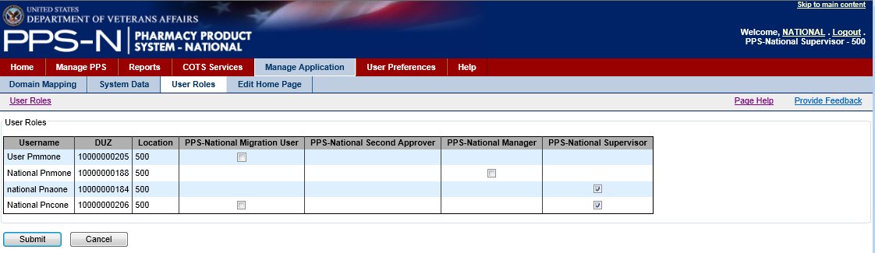

Figure 90: User Roles Tab

There are five user roles in PPS-N that are managed in the application by the administrators..

Table 11: PPS-N User Roles

| **Role** | **Security Key** | **Description** |
| --- | --- | --- |
| PPS National Viewer | PSS_PPSN_VIEWER | This role is designed for a user who needs access to PPS-N to view drugs and their attributes. This user can use the search features and view drugs, but cannot modify or add new drugs to the system. The user can use advanced search and create their own personal search templates and can use the FDB First Databank Search features. This user does have the ability to submit a change request for a drug. This user has the ability to view and create reports. |
| PPS National Second Approver | PSS_PPSN_ SECOND_APPROVER | This role contains all the functionality of a PPS National Viewer and allows a user to conduct a second approval on items that are in the Pending second approval state. The user can search for and view all requests, but they can only approve or disapprove the ones that are available for second approval. |
| PPS National Manager | PSS_PPSN_ MANAGER | The PPS National Manager is the role that controls the normal processing of drug items. This role contains all the functionality of the PPS National Second Approver plus the ability to add and approve all items including new domains such as generic names, ingredients, drug classes, etc. This role also allows the user to look up new items in FDB and add them to PPS-N Enterprise Product List. This role allows the user to save and retrieve partially modified items. |
| PPS National Supervisor | PSS_PPSN_ SUPERVISOR | This role contains all of the permissions of a PPS National Manager. In addition, the role provides access to the Manage Application tab for domain mapping, system data control, assigning user roles, and editing the home page content. In addition this role allows the user to create system level advanced search templates and delete templates that other users have created. This role can also delete partially saved items that other users have saved. |
| PPS National Migrator | PSS_PPSN_MIGRATOR | This role contains all the permissions of the PPS National Viewer and provides access to the Migration tab to perform those functions. |

Each user of PPS-N will need at least one of these roles, and can be assigned multiple roles. When the user first logs into PPS-N, they will only get the permissions of PPS National Viewer. Before they can access the functionality of those additional roles, a PPS-N Supervisor must access this page and check the checkbox giving them the appropriate role(s).

#### User Role Table Columns

The user roles table contains a number of columns:

* First name – The first name of the user, sent by IAM SSOi.
* Last name – The last name of the user, sent by IAM SSOi
* User Name: First Name_Last Name – set by PPS-N.
* VAUID – The Active Directory VAUID of the user, sent by IAM SSOi
* Roles – The user’s assigned roles, as assigned by PBM NDF Managers.

Granting Permissions

The user will access this tab and check the appropriate checkboxes for each user. The user will then click the “Submit” button to save the changes to the database.

### Edit Home Page Tab – for Supervisor Roles Only

The user will access the Edit Home Page tab to change the content for the Home tab.

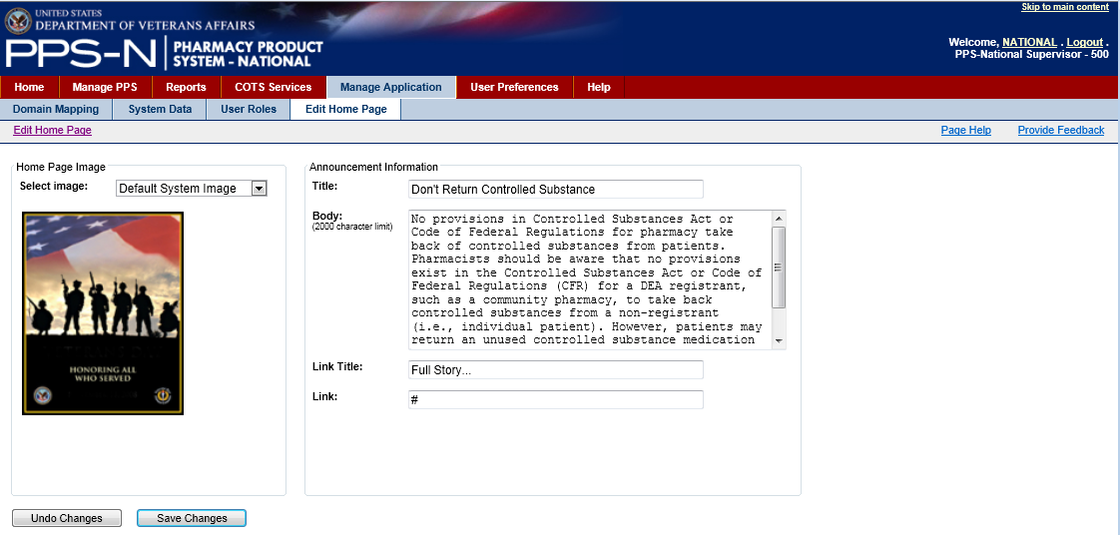

Figure 91: Edit Home Tab Content

There are two primary features of the home page. The first is an optional image, as shown in the left panel above. The second feature is the text that is aligned to the right of the image on the Home tab. The user can use the form shown in the right panel above to enter a title, a certain amount of body text, a link title, and then the URL for the link to the full story or article.

When the user has made the desired changes, the user will click the “Save Changes” button. The user may also undo the changes by clicking the “Undo Changes” button.